THE UNIVERSITY OF DA NANG
VN-UK INSTITUTE FOR RESEARCH AND EXECUTIVE EDUCATION
________________________________
FINAL EXAMINATION — CREATIVE PROJECT
Introduction to Human–Computer Interaction
Opportunities
A multifunction note-taking app — capture anything, find it in seconds, never lose it
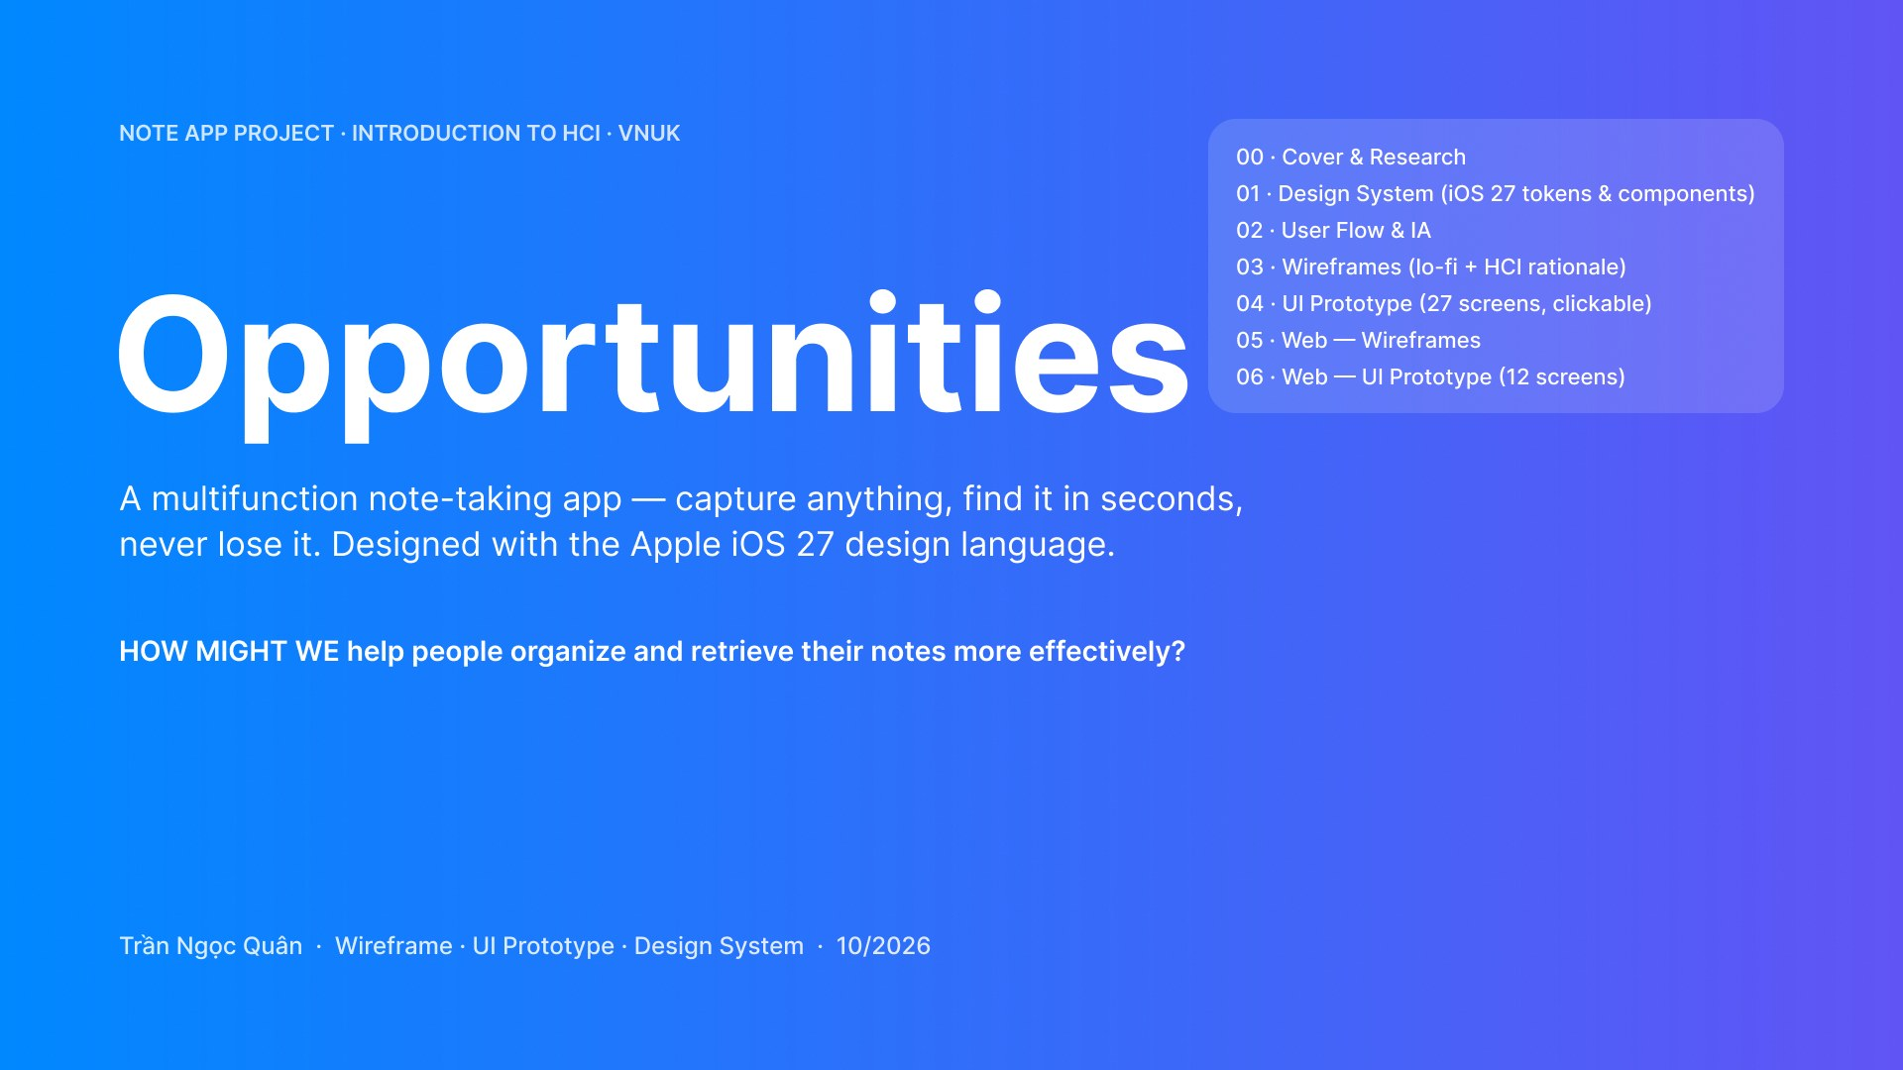
Figure 1. Project cover (Figma)

Student | Trần Ngọc Quân
Student number | ……………………
Class | ……………………
Lecturer | Nguyen Thi Diem Chi (Chi Nguyen)
Module | Introduction to Human–Computer Interaction — Final project (60%)
Submitted | October 2026

TABLE OF CONTENTS
PART 1 – ESSAY 3
I. Brief of the project 3
Background 3
Problem → Solution 4
II. Analyze 5
A. Scenarios 5
B. Persona 5
C. Sympathy map 9
D. Feature list 10
III. Produce 12
A. Flow chart 12
B. UX wireframe 18
IV. Test cases 28
PART 2 – PROTOTYPE 31
Visual design system 31
I. Mobile app 33
II. Web 37

(Right-click the table → Update Field to refresh page numbers.)

PART 1 – ESSAY

I. Brief of the project

Background
- Students and young professionals take notes everywhere: typed lecture notes on a laptop, whiteboard photos on the phone, ideas dictated on the bus, checklists in chat apps and tuition records in a paper notebook.
- Because this information is spread across five or more tools, people waste time searching, forget deadlines, and lose notes when a phone is reset or Wi-Fi is weak.
- Handwritten notes, screenshots and scans cannot be searched, and typing formulas or tables on a phone is painful.
- Existing workspace apps are powerful but feel heavy for casual users, while simple apps lack structure and offline reliability.
How might we help people organize and retrieve their notes more effectively?
- A. Project: Opportunities — multifunction note-taking app (iOS mobile + desktop web app)
- B. Brand: Opportunities — “every note is an opportunity you don’t lose”
- C. Client: University students, part-time tutors and young professionals who manage study, work and personal notes
- D. Project descriptions:
  - Quick Capture in two taps: text, checklist, whiteboard scan, voice, drawing and table
  - Scan whiteboards with edge detection; on-device text recognition makes photos and handwriting searchable
  - Organize with folders, nested tags, colour labels, pins and [[links]] between notes
  - Checklist items with reminders and one “what’s due” Tasks view across all notes
  - Math palette for formulas (no LaTeX needed) and a Markdown/LaTeX source mode for power users
  - Offline-first auto-save, sync between phone and laptop, version history and a 30-day trash
  - Tutoring templates: lesson plan, attendance and a tuition table with automatic totals
  - Share read-only links, export PDF / Markdown; Dark mode and Focus mode
- E. Budget: N/A (academic project)
- F. Brand background: Designed by Trần Ngọc Quân for the HCI course at VNUK, 2026. Motto: “Capture anything. Find it in seconds. Never lose it.”
- G. Target audience:
  - Primary — busy, mid-tech students who also tutor part-time (persona Trần Minh Thư)
  - Secondary — keyboard-first power users who write Markdown and LaTeX (persona Phạm Đức Anh)
- H. Coverage: Vietnamese students and young professionals; UI in Vietnamese with English as an option
- I. Timing: Research and analysis → wireframes → hi-fi prototype → heuristic evaluation and v2 re-design (October 2026)
- J. Description (platform):
  - Mobile: iPhone 17 Pro (402 × 874 pt) built with the Apple iOS & iPadOS 27 UI kit (Liquid Glass, SF type scale, system colours)
  - Web: desktop web app 1440 × 900, 3-column workspace (sidebar · list · editor) with keyboard shortcuts
  - Tools: Figma (design system, wireframes, prototype), draw.io (diagrams)
- K. Objective:
  - Reduce the number of apps users need to one, and let them capture any note in ≤ 2 taps
  - Let users find any note — including text inside photos — in ≤ 2 seconds / ≤ 3 actions
  - Never lose a note: offline-first saving, sync, version history and undo
  - Stay simple for beginners and powerful for experts (Simple ↔ Markdown modes)

Problem → Solution
Problem | Solution — Opportunities | Success metric
Notes are stored in different places; handwriting, screenshots and scans are not searchable; typing is slow when busy; users forget deadlines, lose data, cannot work offline; many apps are too complicated. | One platform for text, voice, photos, scans, drawings, checklists and tables; folders, tags, colours, pins and links; text search inside photos, reminders, auto-save, offline access, phone ↔ web sync, themes, text size and focus mode. | Capture ≤ 2 taps · find a note ≤ 2 s · 0 notes lost · formula inserted without typing code · SUS ≥ 80

II. Analyze

A. Scenarios
Scenario 1 — Trần Minh Thư (primary persona): a Thursday of lectures, tutoring and exam revision
- Step 1 (07:55, on the bus): Thư opens Opportunities from the home-screen widget and taps “+” → Voice. She says “Remind Minh to do exercise 2.4, quiz on Thursday”. The app transcribes it and shows “I understood: add task, remind Thursday 19:00, save to Tutoring › Minh”. She taps Save.
- Step 2 (09:40, in class): The lecturer writes on the whiteboard. Thư taps + → Scan. The camera detects the board’s edges and captures automatically; a progress card shows “Recognizing text… line 2/4 — works offline”.
- Step 3 (09:42): On Review Scan she corrects one word, chooses folder Lecture › Giải tích 2 and tag #calculus, then taps Save. The badge shows “Saved on iPhone”.
- Step 4 (09:45): In the note editor (Live Preview) she needs a formula. She opens the math palette, taps ∫, fills the limits 0 and 2π and taps Insert — no LaTeX typed. She also sketches a graph with Drawing and converts her handwritten “y = x² − 2x” into a formula.
- Step 5 (12:30, canteen without Wi-Fi): A banner says “Offline — still saved on this phone; 3 changes will sync when online”. She keeps working.
- Step 6 (17:30): A lock-screen notification “Collect October fee — Minh, 18:00” appears. She taps “Paid ✓”; the tuition table updates its total automatically.
- Step 7 (20:30, laptop): She opens the web app. Because she edited the same note offline, a merge dialog lets her keep lines from both versions — nothing is lost.
- Step 8 (23:00): She turns on Dark + Focus mode and searches “tích phân”; results include the text recognized in this morning’s whiteboard photo, highlighted.
Scenario 2 — Phạm Đức Anh (power user): writing his thesis note
- Step 1: On his MacBook he opens the web app and presses ⌘K (Ctrl K on Windows) to open the command palette, types “ins” and chooses Insert formula.
- Step 2: He switches to Source mode (⌘E). Typing \fr shows LaTeX autocomplete; Tab inserts \frac{▢}{▢} with placeholders. The right pane previews the rendered equation (1).
- Step 3: He links related notes with [[Bài tập chương 3]]; the backlinks panel shows the notes that mention this one.
- Step 4: He right-clicks the note → Export PDF / Markdown (Ctrl ⇧ E) and sends a read-only link to his advisor.

B. Persona
Two personas were built from the user research. Thư is the primary persona (most design decisions are optimised for her); Đức Anh is the power-user persona who validates advanced features.
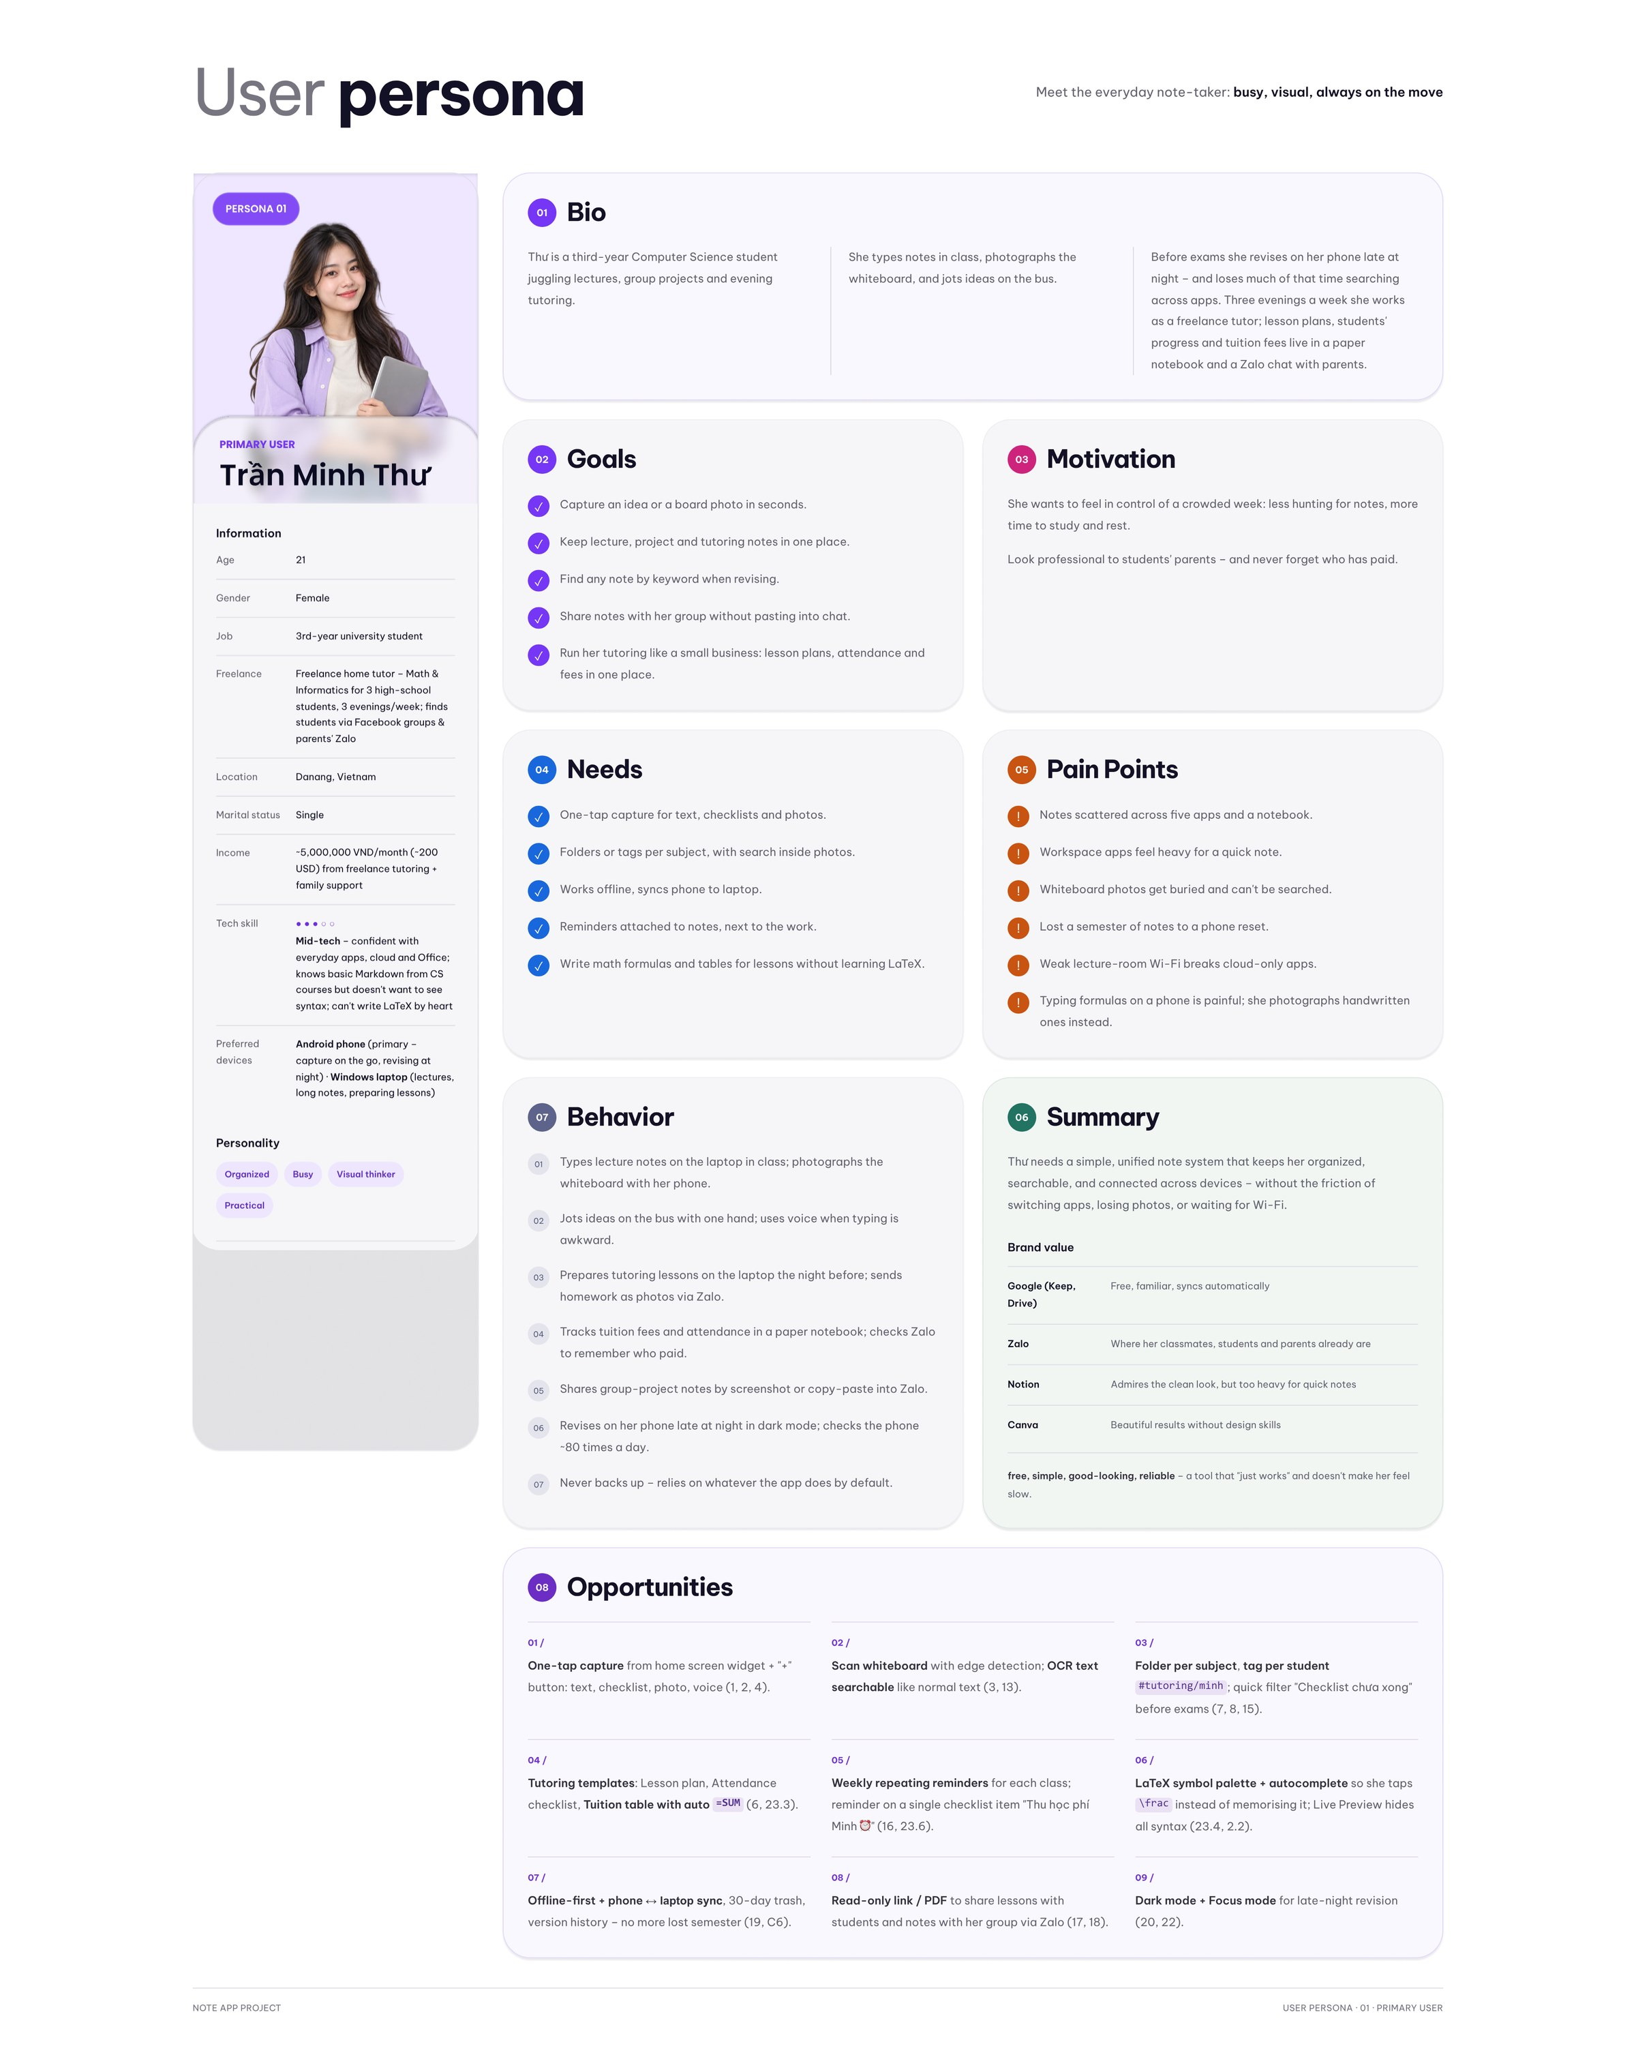
Figure 2. Persona 01 — Trần Minh Thư, primary user (busy, visual, always on the move)
Field | Trần Minh Thư — Persona 01 (Primary)
Overall description | 21, female, Danang. 3rd-year Computer Science student and freelance home tutor (Math & Informatics, 3 evenings/week). Mid-tech: confident with everyday apps, knows basic Markdown but does not want to see syntax and cannot write LaTeX by heart. Android phone + Windows laptop.
Goals | • Capture an idea or board photo in seconds  • Keep lecture, project and tutoring notes in one place  • Find any note by keyword when revising  • Share notes with her group without pasting into chat  • Run tutoring like a small business: lesson plans, attendance and fees in one place
Pain points | • Notes scattered across five apps and a notebook  • Workspace apps feel heavy for a quick note  • Whiteboard photos get buried and can’t be searched  • Lost a semester of notes to a phone reset  • Weak lecture-room Wi-Fi breaks cloud-only apps  • Typing formulas on a phone is painful
Needs | One-tap capture; folders/tags per subject with search inside photos; works offline and syncs; reminders next to the work; formulas and tables without LaTeX

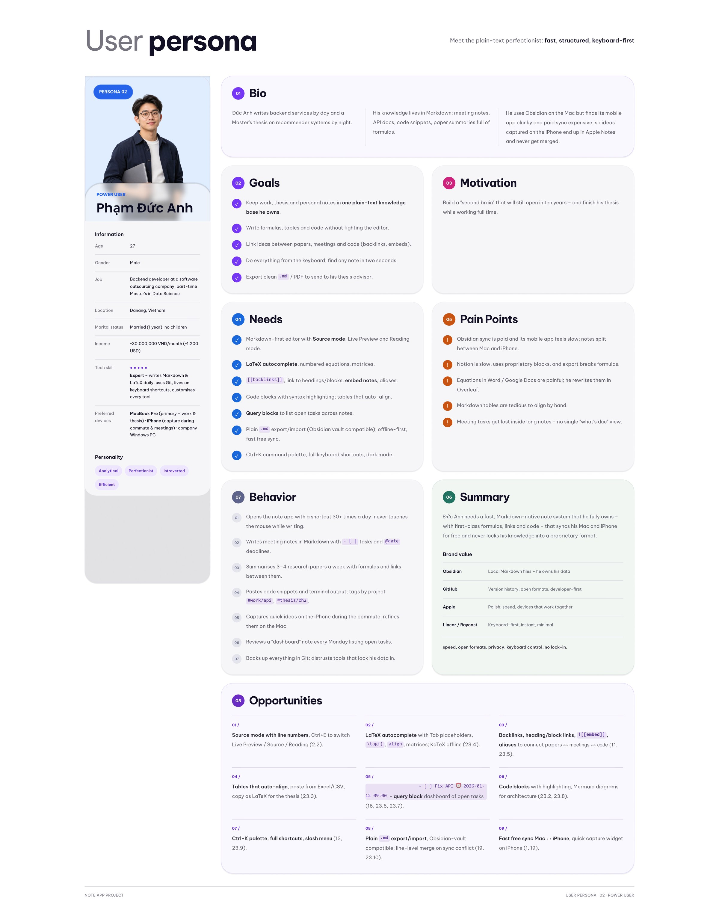
Figure 3. Persona 02 — Phạm Đức Anh, power user (fast, structured, keyboard-first)
Field | Phạm Đức Anh — Persona 02 (Power user)
Overall description | 27, male, Danang. Backend developer and part-time Master’s student in Data Science. Expert: writes Markdown and LaTeX daily, uses Git, lives on keyboard shortcuts. MacBook Pro + iPhone.
Goals | • Keep work, thesis and personal notes in one plain-text knowledge base he owns  • Write formulas, tables and code without fighting the editor  • Link ideas between papers, meetings and code  • Do everything from the keyboard; find any note in two seconds  • Export clean .md / PDF for his thesis advisor
Pain points | • Obsidian sync is paid and its mobile app feels slow  • Notion is slow and export breaks formulas  • Markdown tables are tedious to align by hand  • Meeting tasks get lost inside long notes — no single “what’s due” view
Needs | Markdown-first editor with Live Preview / Source / Reading; LaTeX autocomplete; [[backlinks]]; query of open tasks; plain .md export; fast free sync; Ctrl/⌘ K palette and dark mode

C. Sympathy map
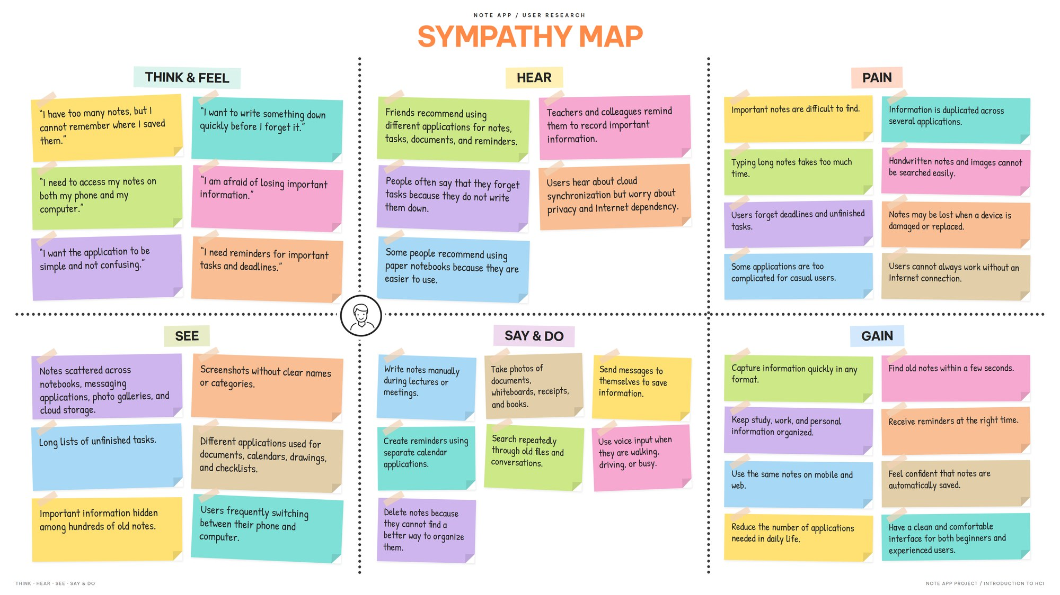
Figure 4. Sympathy map — note app user research (Think & Feel, Hear, See, Say & Do, Pain, Gain)
Quadrant | Key insights → design response
Think & Feel | “I have too many notes but can’t remember where I saved them”, “I want to write something down quickly before I forget”, “I’m afraid of losing important information”, “I want it simple, not confusing” → Quick Capture, search, offline-first + undo, Simple mode
Hear | Friends recommend different apps; teachers remind them to record information; worries about cloud sync and privacy → one app, local-first storage, read-only sharing
See | Notes scattered across notebooks, chat apps, galleries and cloud; screenshots without names; long lists of unfinished tasks → folders, tags, OCR, Tasks view
Say & Do | Write manually in lectures, photograph documents and whiteboards, send messages to themselves, search repeatedly through old files, use voice when busy → scan, voice capture, smart filters
Pain | Important notes are hard to find; typing long notes takes time; forget deadlines; handwriting and images can’t be searched; notes lost when a device is replaced; can’t work without Internet
Gain | Capture in any format; find old notes within seconds; keep study/work/personal organized; reminders at the right time; same notes on mobile and web; confident notes are saved automatically; clean UI for beginners and experts

D. Feature list
a) Functional
- Quick Capture: Create a note in ≤ 2 taps as text, checklist, scan, voice, drawing or table; templates for lesson plan, attendance and tuition table.
- Scan & text recognition: Document camera with edge detection and auto-capture; on-device recognition (Vietnamese + English); editable recognized text.
- Note editor: Live Preview (no syntax), Source (Markdown + LaTeX autocomplete) and Reading modes; math palette; tables with automatic totals; attachments; [[backlinks]].
- Organize: Folders per subject, nested #tags, colour labels, pins, smart folders (“unfinished checklists”, “has reminder”, “scans & photos”).
- Search: Searches note text and text inside photos/handwriting, with scope filters, highlighted matches and recent searches; works offline.
- Tasks & reminders: Checklist items with date/time, repeat and early reminder; Tasks view (Today, Scheduled, All, Overdue); actionable notifications and a widget.
- Share & export: Read-only link with expiry, PDF with rendered formulas, Markdown export; share to Zalo/Messages/Mail.
- Sync & safety: Offline-first auto-save, sync phone ↔ web, conflict merge line by line, version history, 30-day Recently Deleted, undo toast.
- Comfort: Dark mode, Focus mode, text size, editor style (Simple / Markdown), interface language.
b) Non-functional
- Performance: App opens in < 1 s from local storage; search returns results in ≤ 2 s for 1,000 notes; auto-save within 1 s of typing.
- Reliability: All changes are written locally first; no data loss when offline or on conflict; deleted notes are recoverable for 30 days.
- Usability: Every touch target ≥ 44 × 44 pt; capture ≤ 2 taps; system status always visible; destructive actions confirmed or undoable.
- Accessibility: Dynamic Type text sizes, Dark mode, colour never the only cue (icon + text), keyboard focus states and shortcuts on web.
- Privacy & security: Text recognition runs on-device; shared links are read-only and can expire; user owns and can export all data.
- Consistency: Built on Apple iOS 27 components and system colours; one icon set; Ctrl on Windows, ⌘ on macOS.

III. Produce

A. Flow chart
The interaction was modelled with nine diagrams (draw.io): use case, sequence, user flow, Norman’s interaction model, customer journey map, information architecture, screen flow, state transition and hierarchical task analysis.
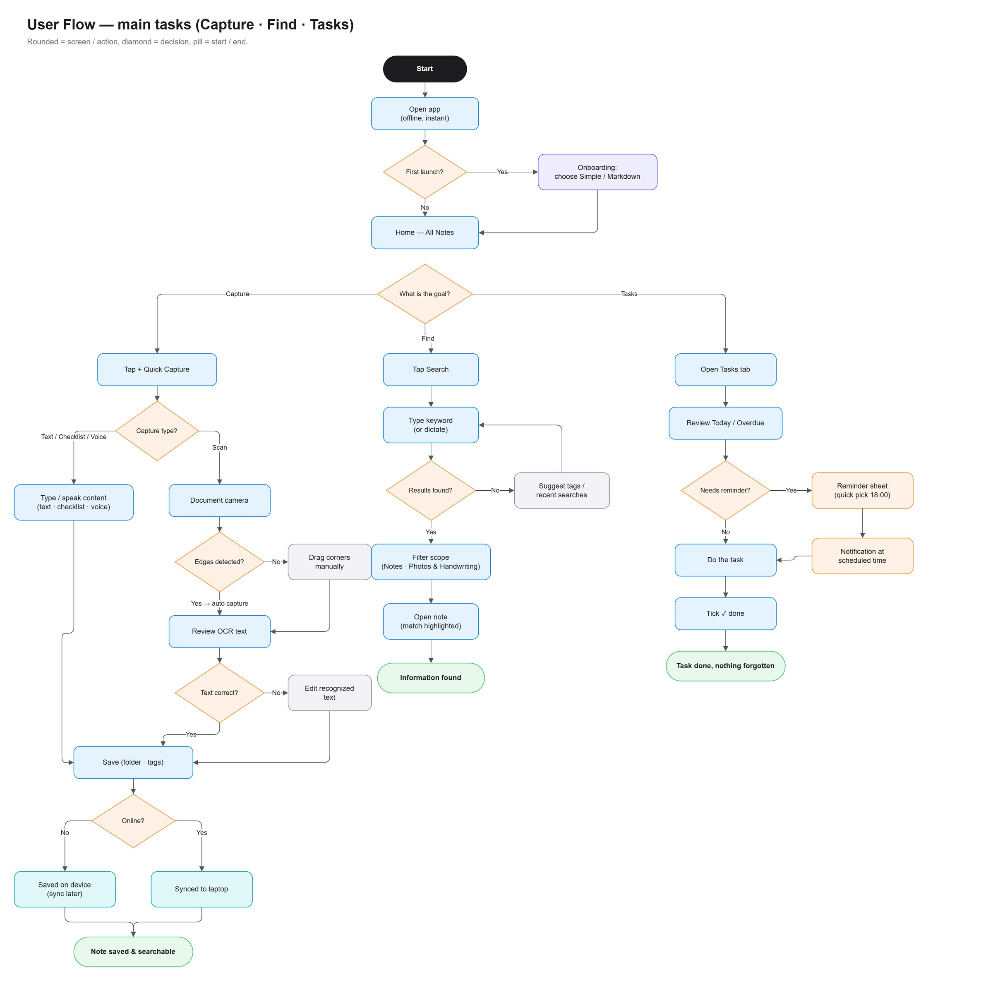
Figure 5. User flow — main tasks Capture · Find · Tasks (rounded = screen/action, diamond = decision)
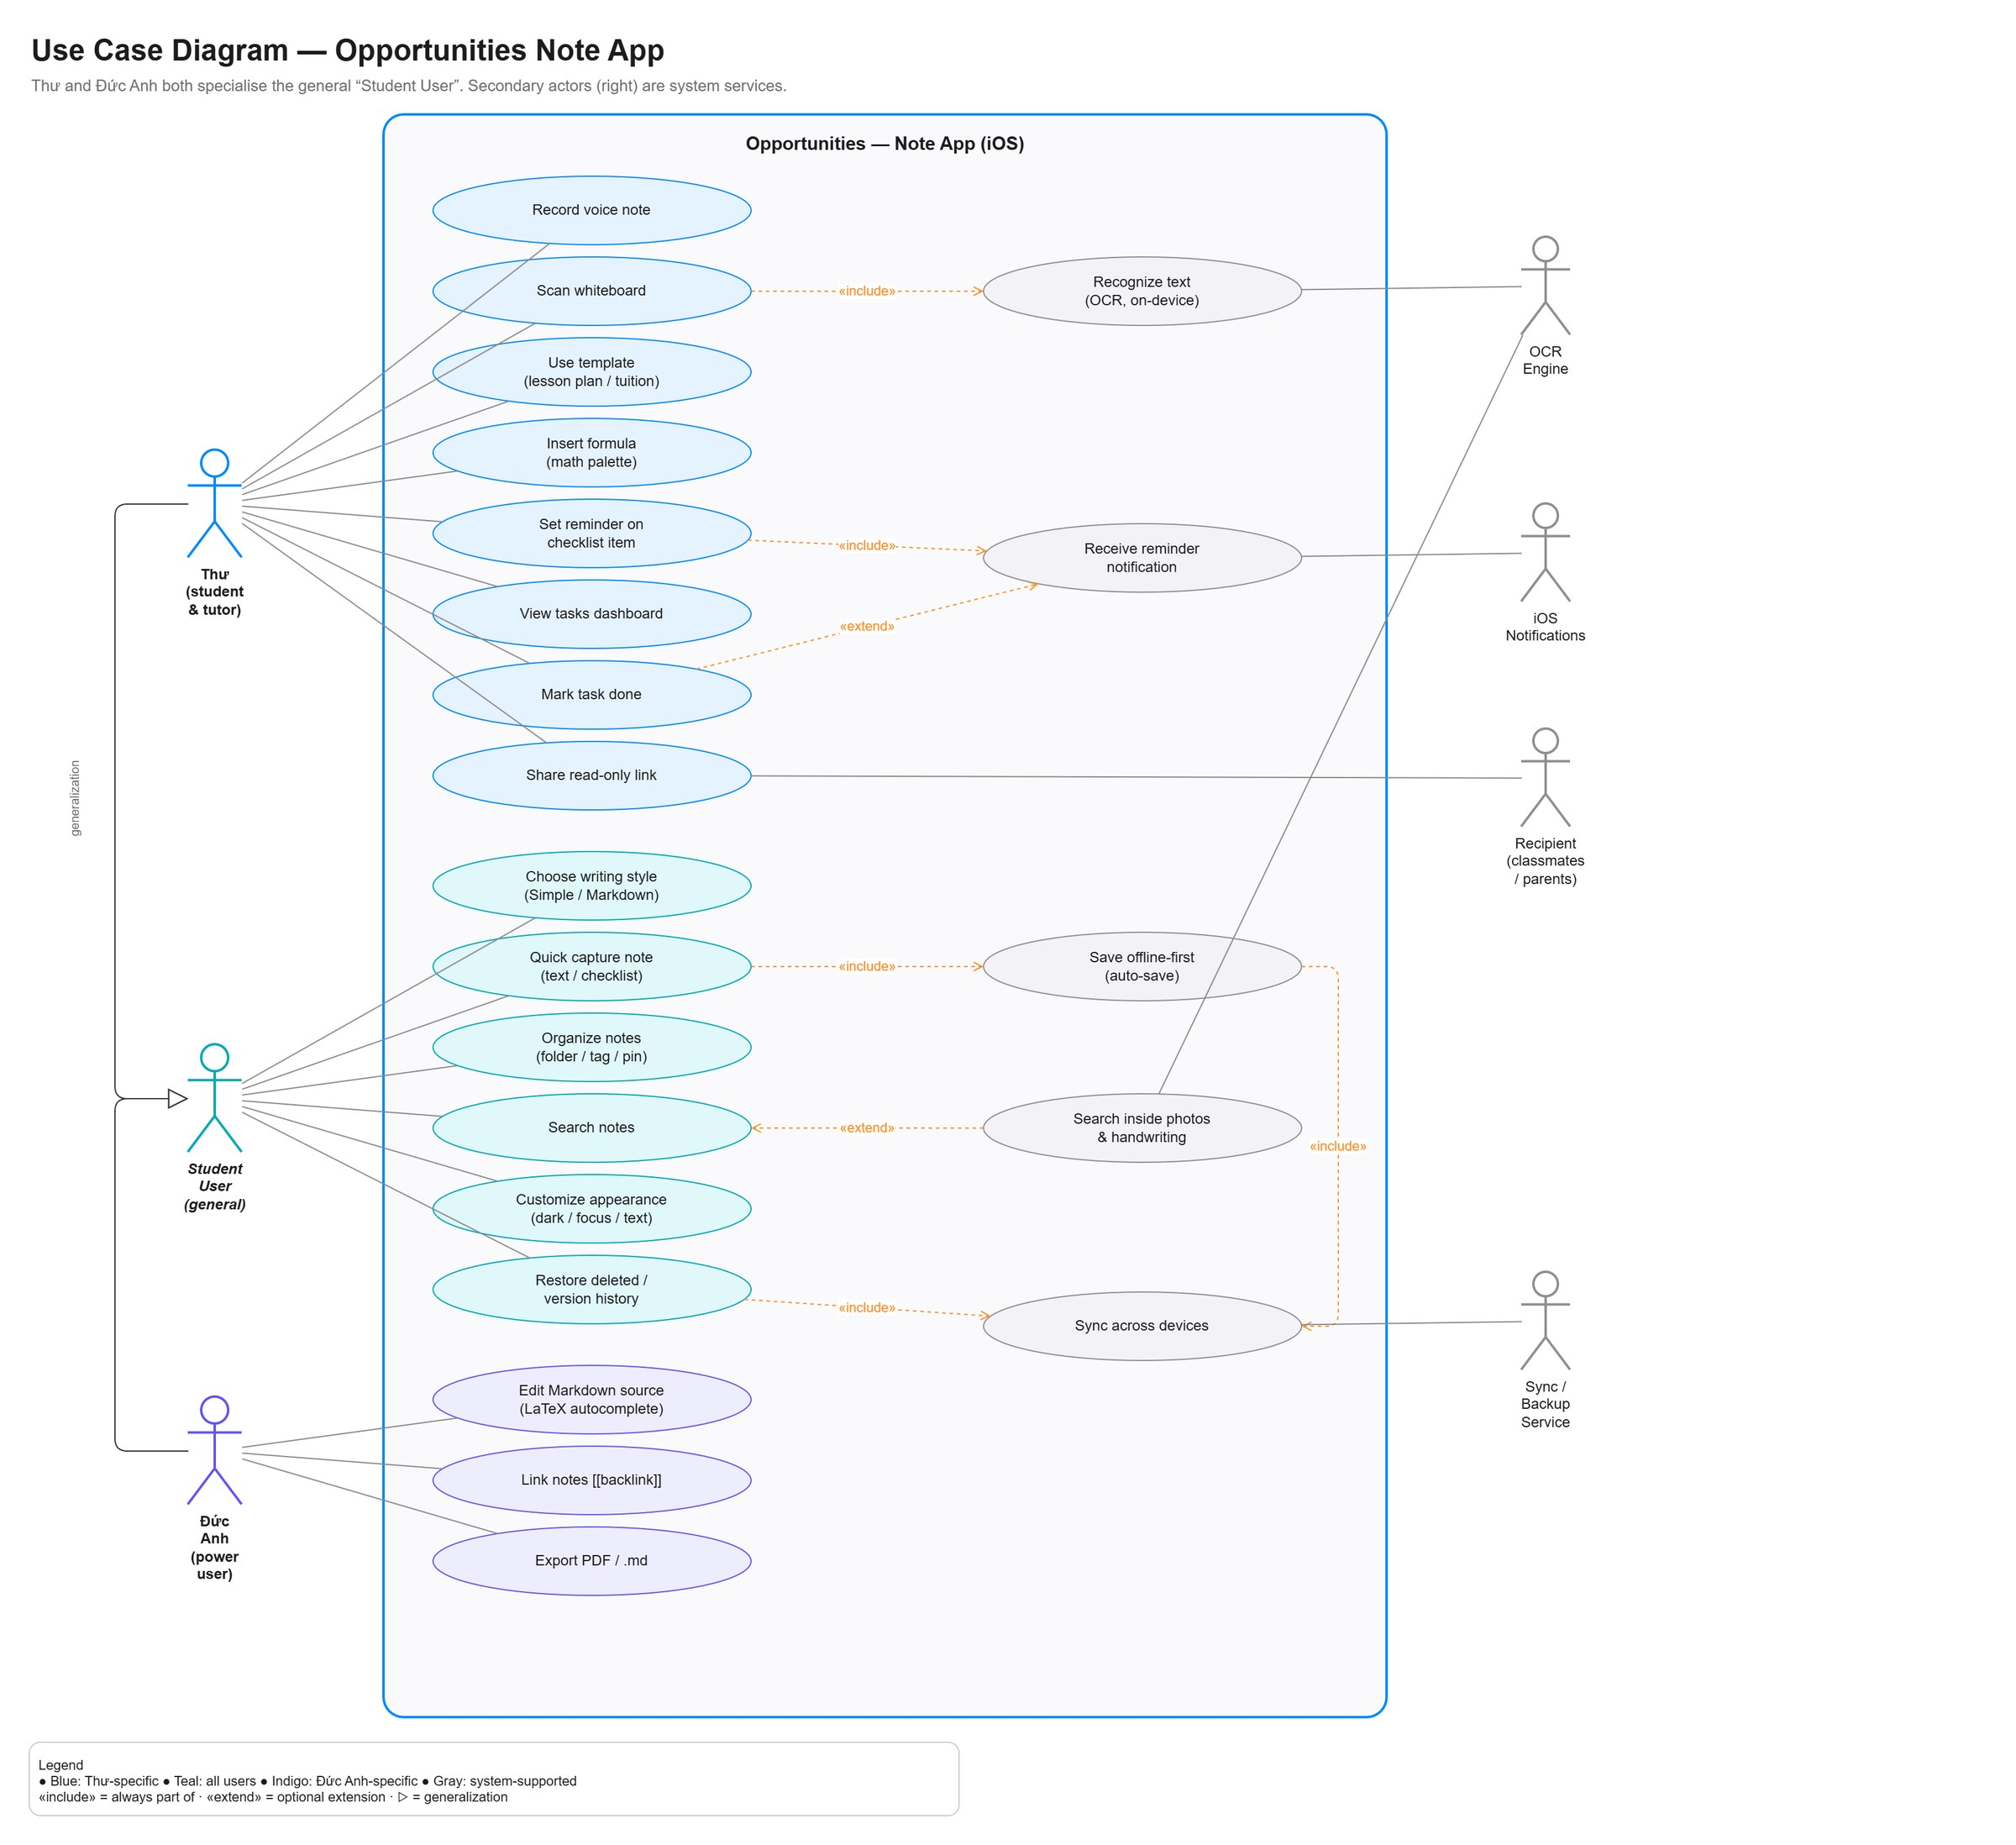
Figure 6. Use case diagram — actors Thư, Đức Anh (specialising Student User) and system services
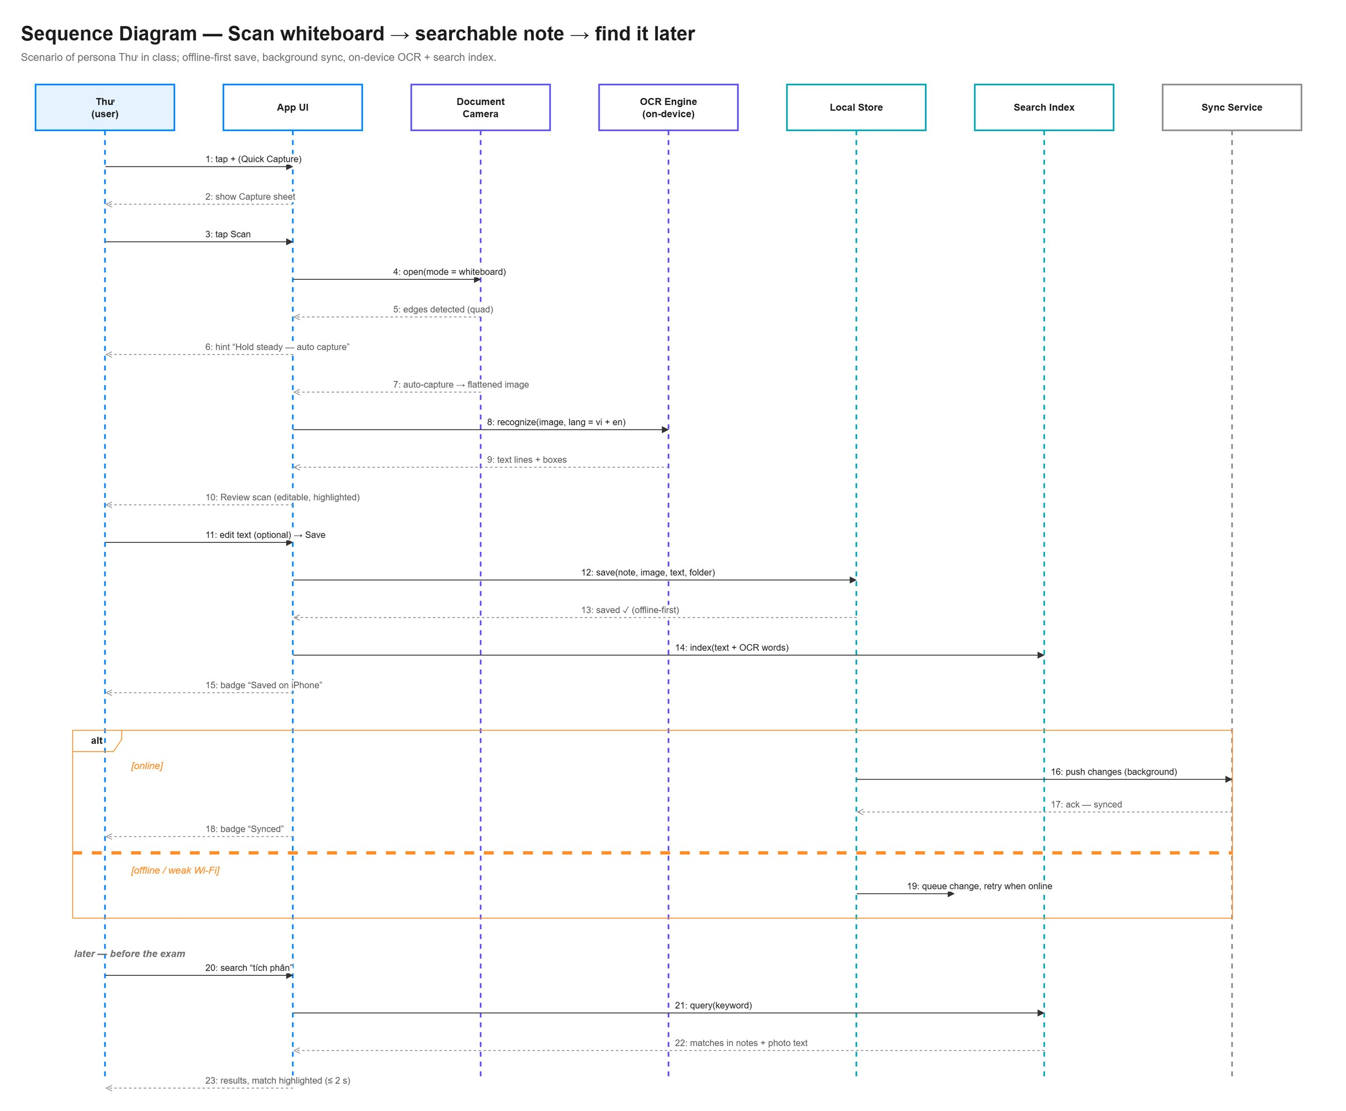
Figure 7. Sequence diagram — scan whiteboard → searchable note → find it later (with offline/online alternative)
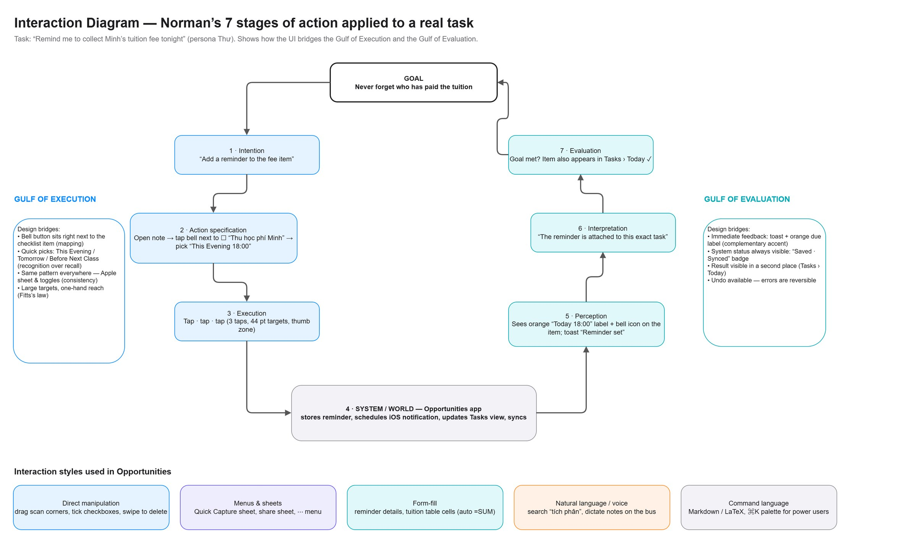
Figure 8. Interaction diagram — Norman’s 7 stages of action for “remind me to collect Minh’s fee tonight”
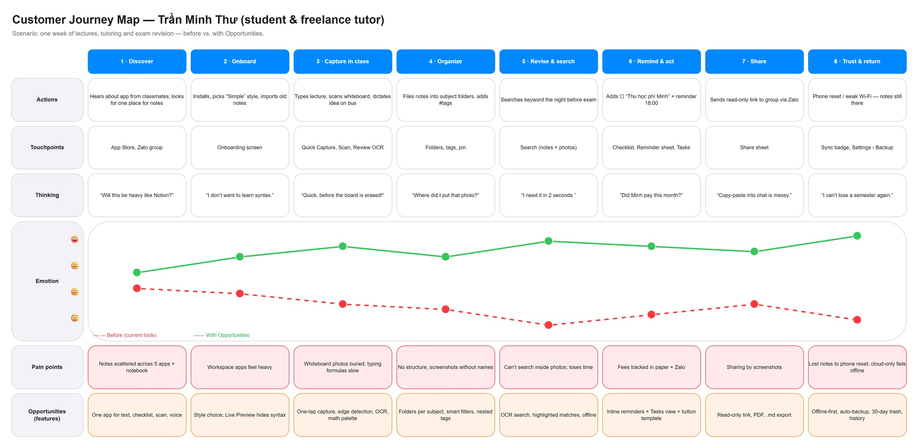
Figure 9. Customer journey map — Trần Minh Thư, before vs. with Opportunities
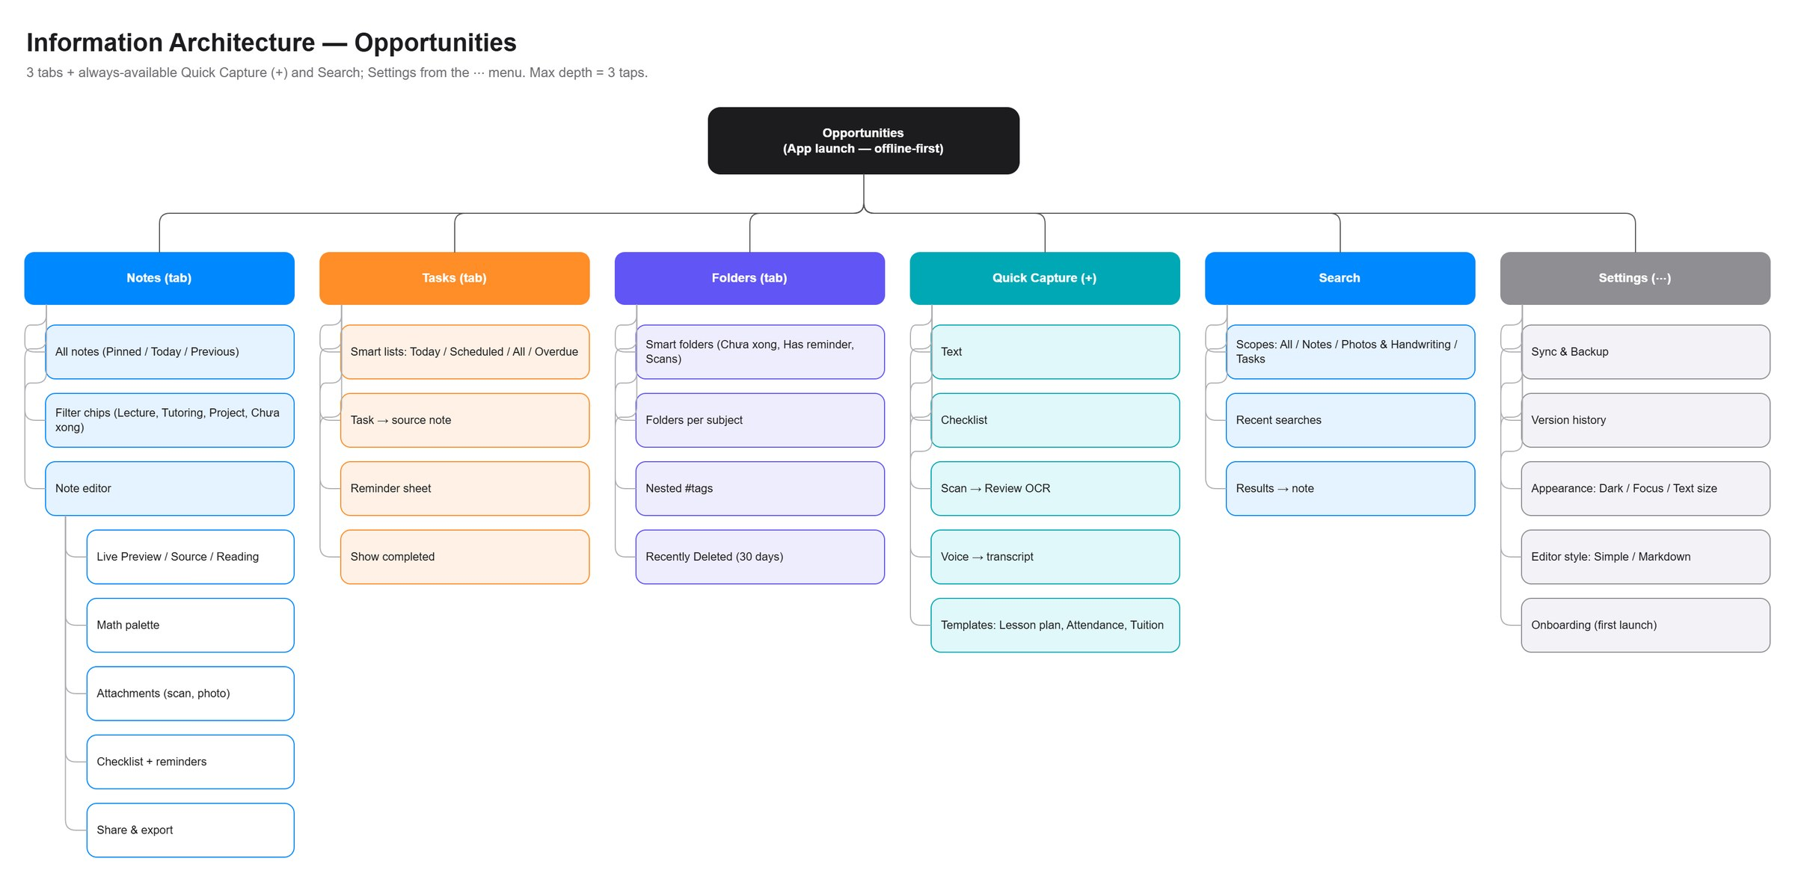
Figure 10. Information architecture — 3 tabs + Quick Capture, Search and Settings (max depth 3 taps)
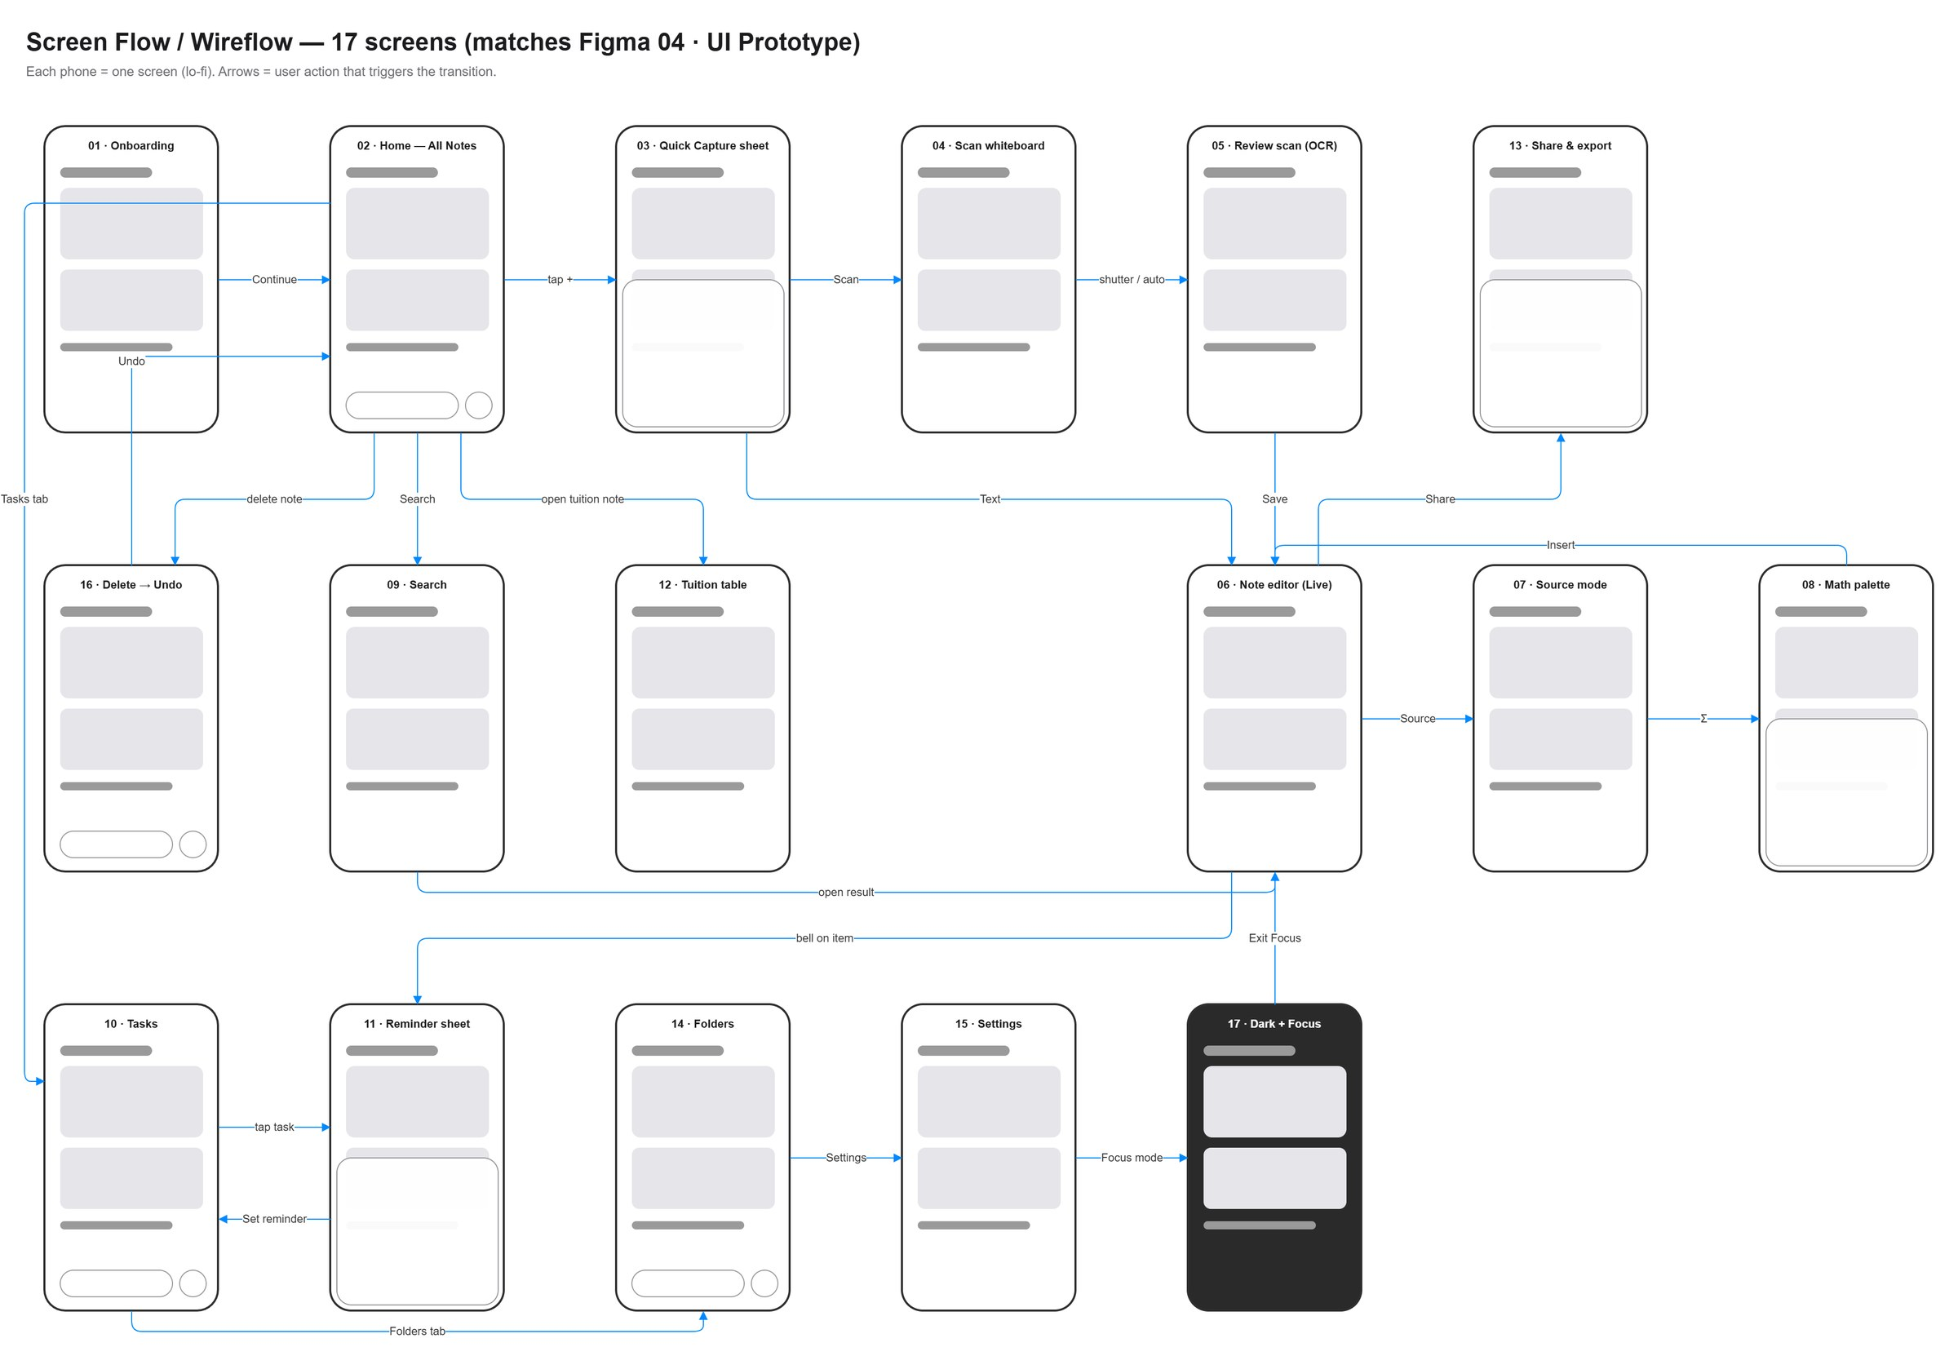
Figure 11. Screen flow / wireflow — screens and the user actions that connect them
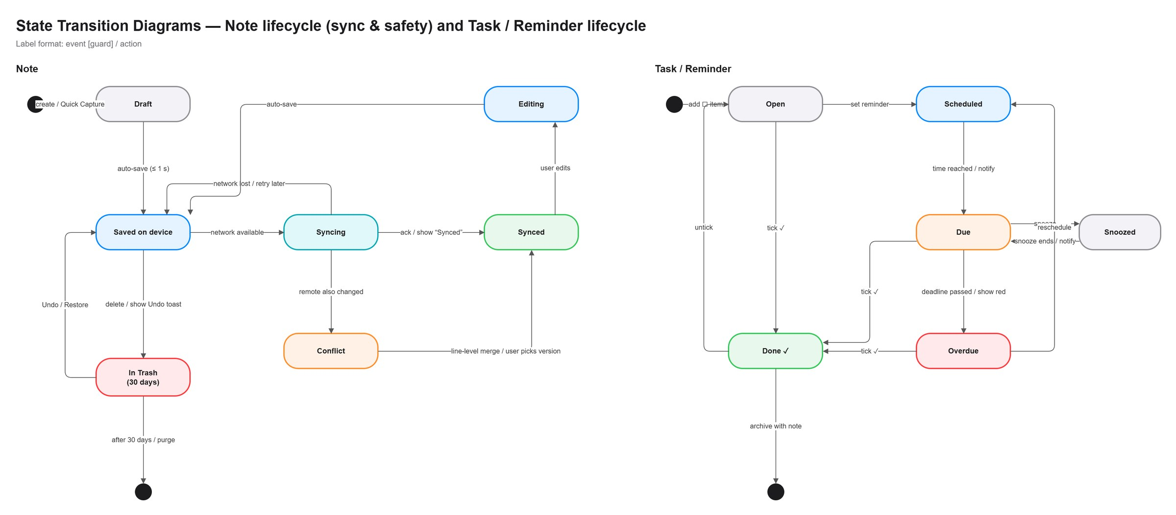
Figure 12. State transition diagrams — note lifecycle (sync & safety) and task/reminder lifecycle
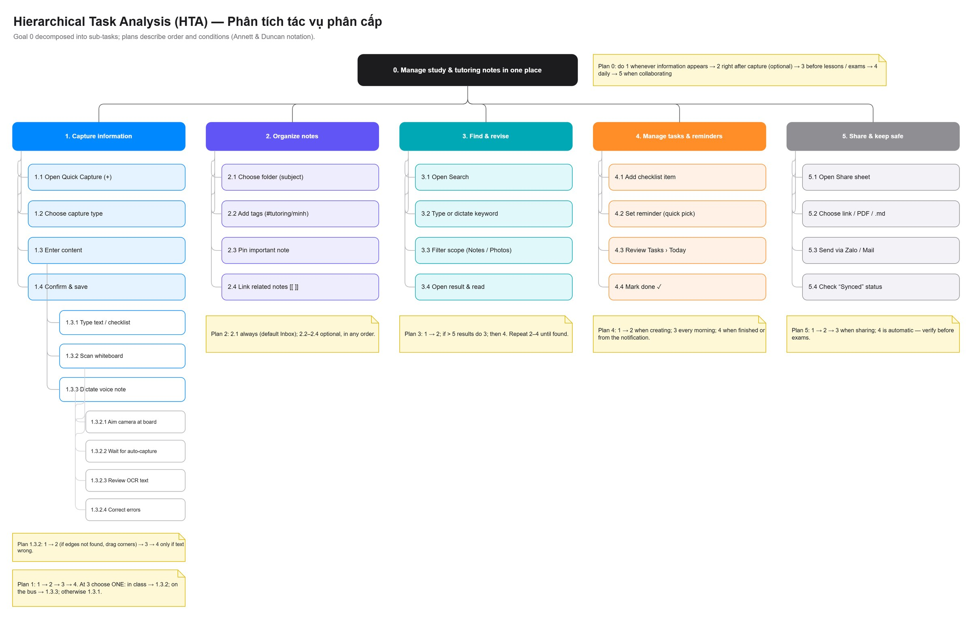
Figure 13. Hierarchical task analysis (HTA) — goal 0 “Manage study & tutoring notes in one place” with plans

B. UX wireframe
Low-fidelity wireframes use only grey blocks (bars = text, boxes = content, circles = buttons) to show structure before visual design. Each wireframe is annotated with the HCI principle applied, the design decision and the persona pain point it answers.
Mobile app wireframes (iPhone, 27 screens)
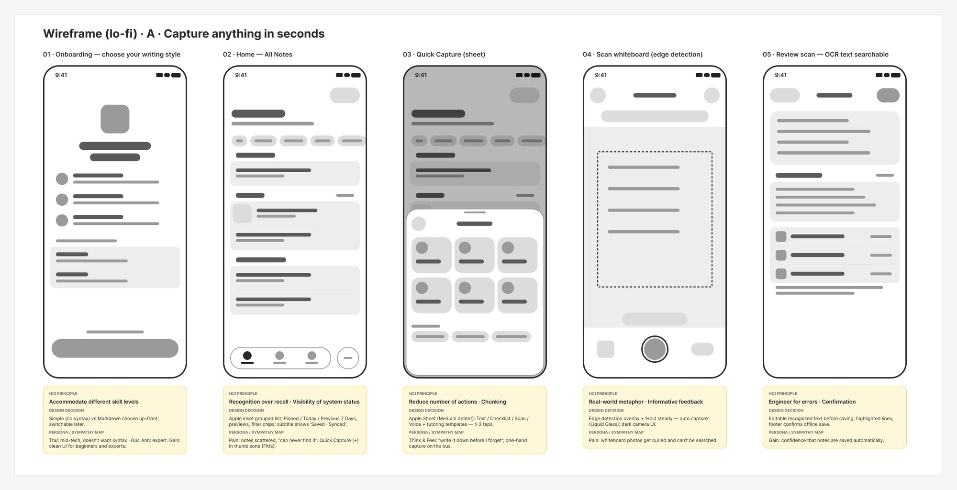
Figure 14. Mobile wireframes A — Capture anything in seconds (onboarding, home, quick capture, scan, review)
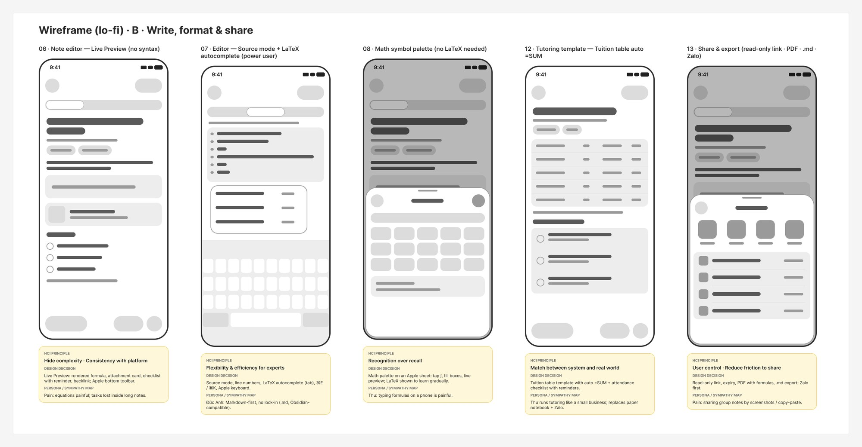
Figure 15. Mobile wireframes B — Write, format & share (editor, source mode, math palette, tuition table, share)
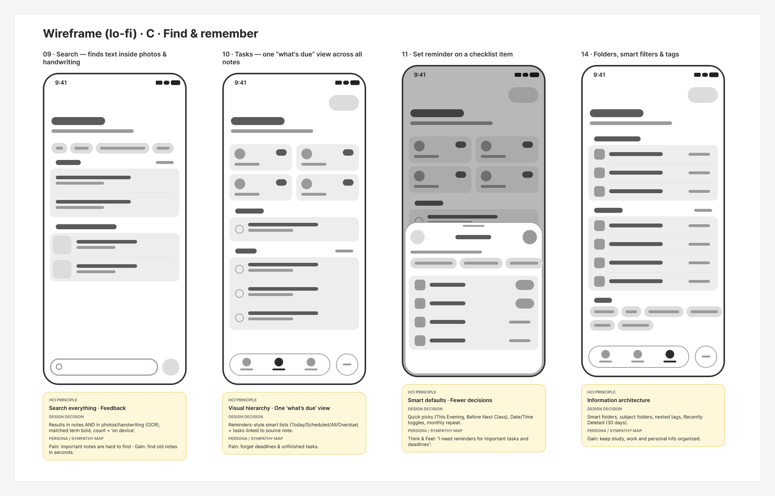
Figure 16. Mobile wireframes C — Find & remember (search, tasks, reminder, folders)
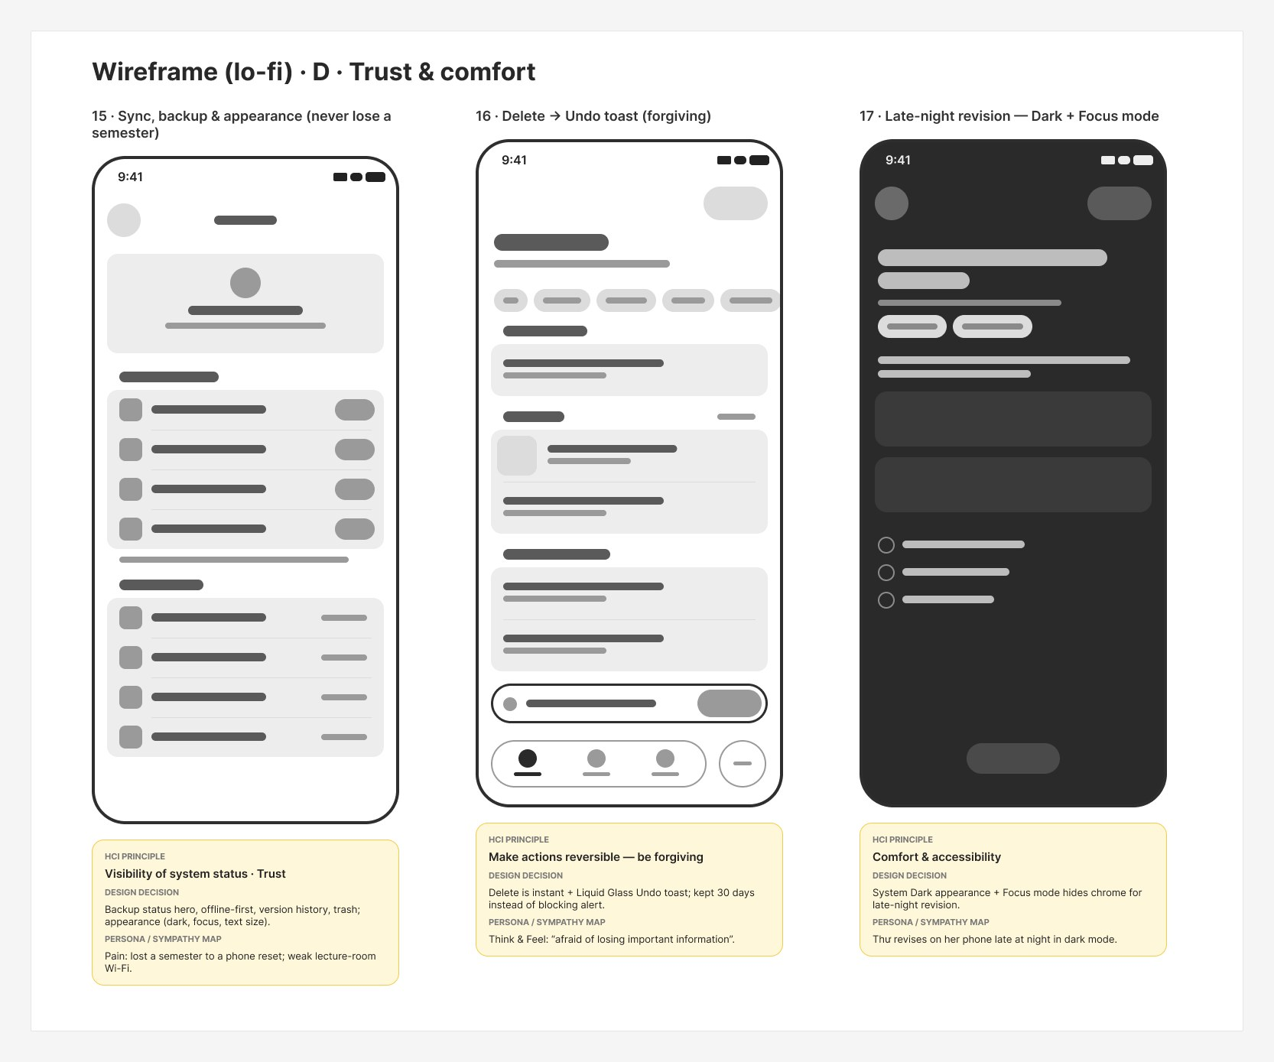
Figure 17. Mobile wireframes D — Trust & comfort (settings, undo, dark + focus)
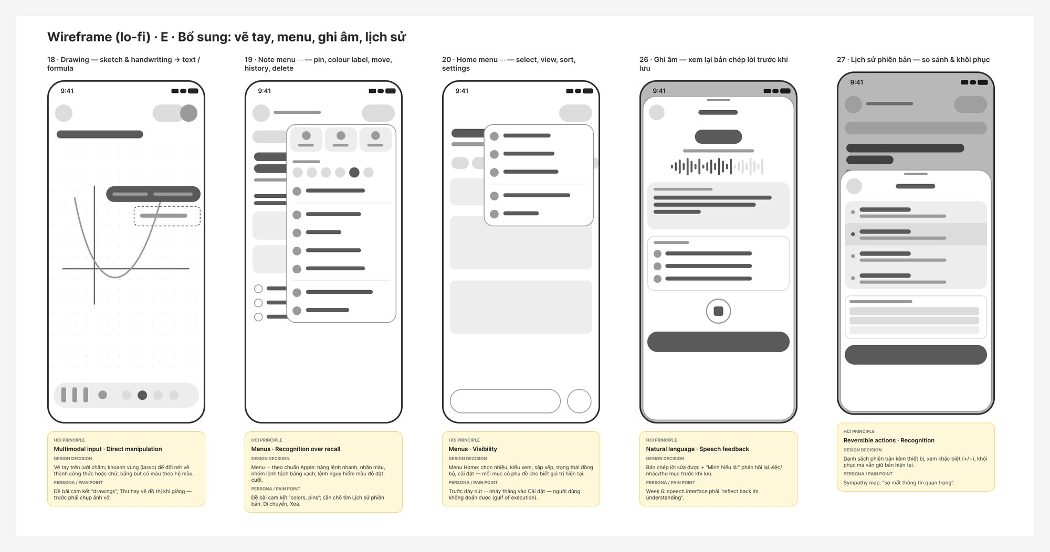
Figure 18. Mobile wireframes E — Drawing, menus, voice note, version history
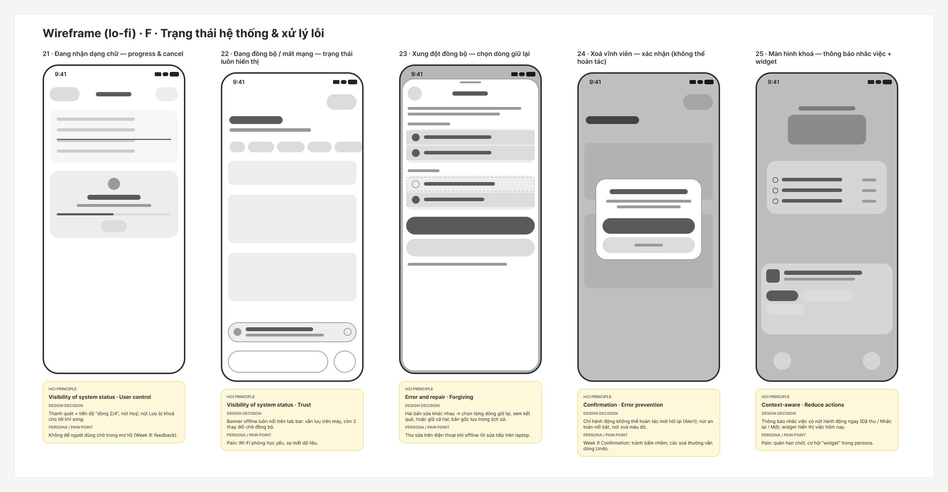
Figure 19. Mobile wireframes F — System status & error handling (processing, offline, conflict, confirmation, notification)
Web app wireframes (desktop, 12 screens)
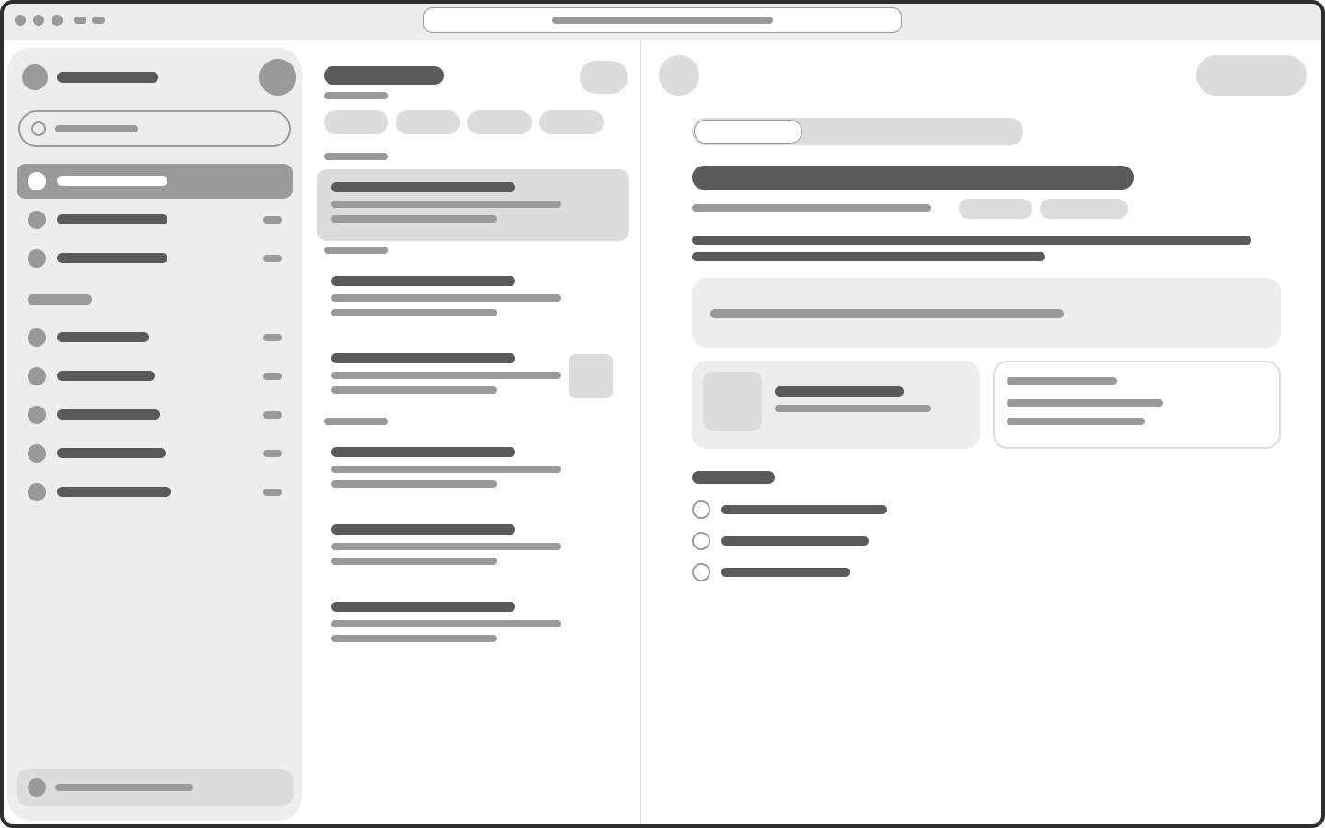
Figure 20. Web wireframe W01 Notes — sidebar · list · editor
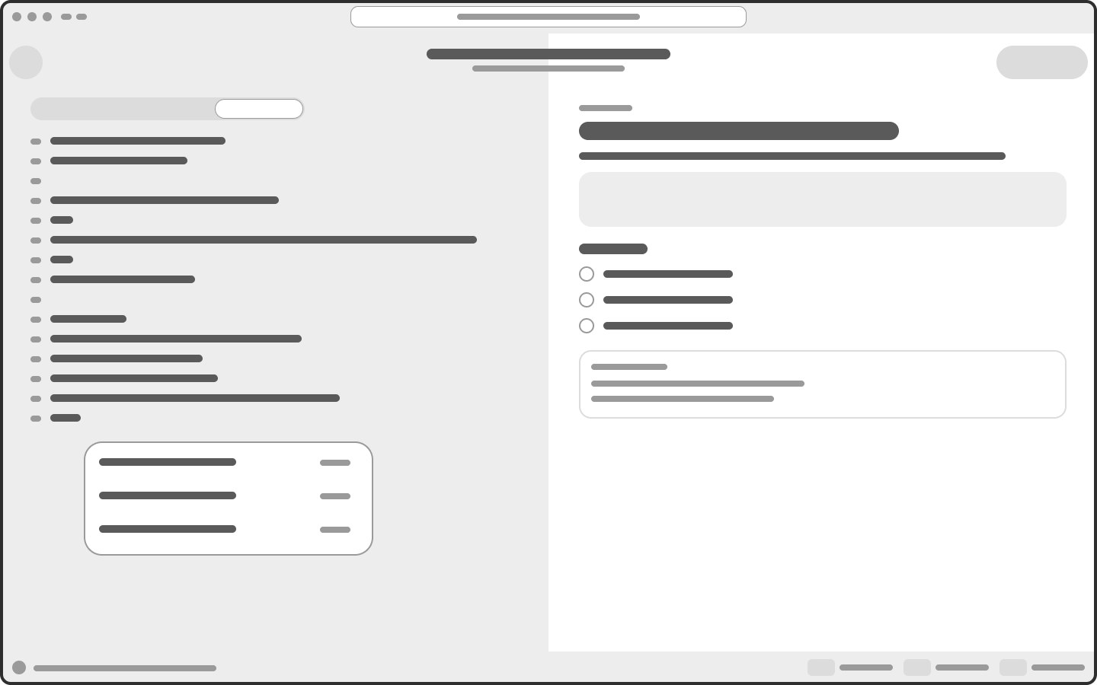
Figure 21. Web wireframe W02 Editor — Source | Preview split
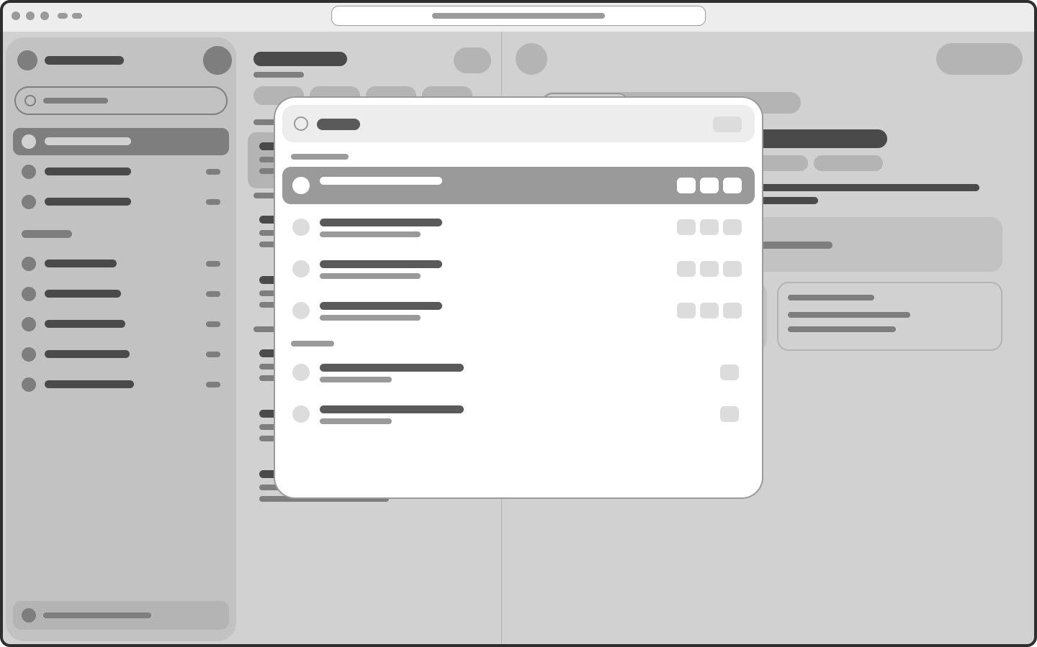
Figure 22. Web wireframe W03 Command palette Ctrl K
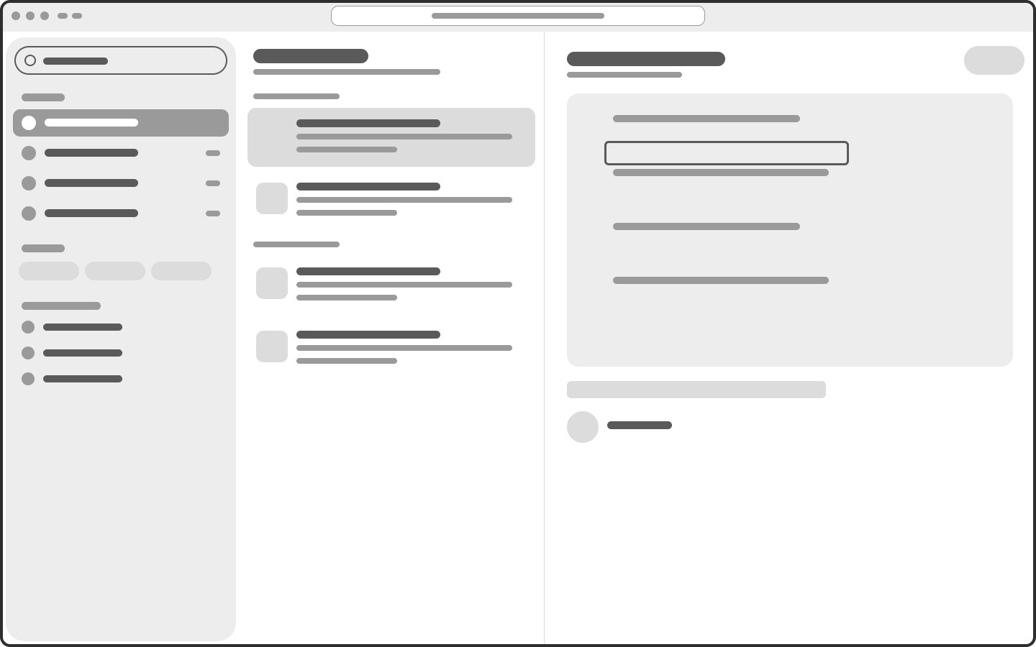
Figure 23. Web wireframe W04 Search — photos & handwriting
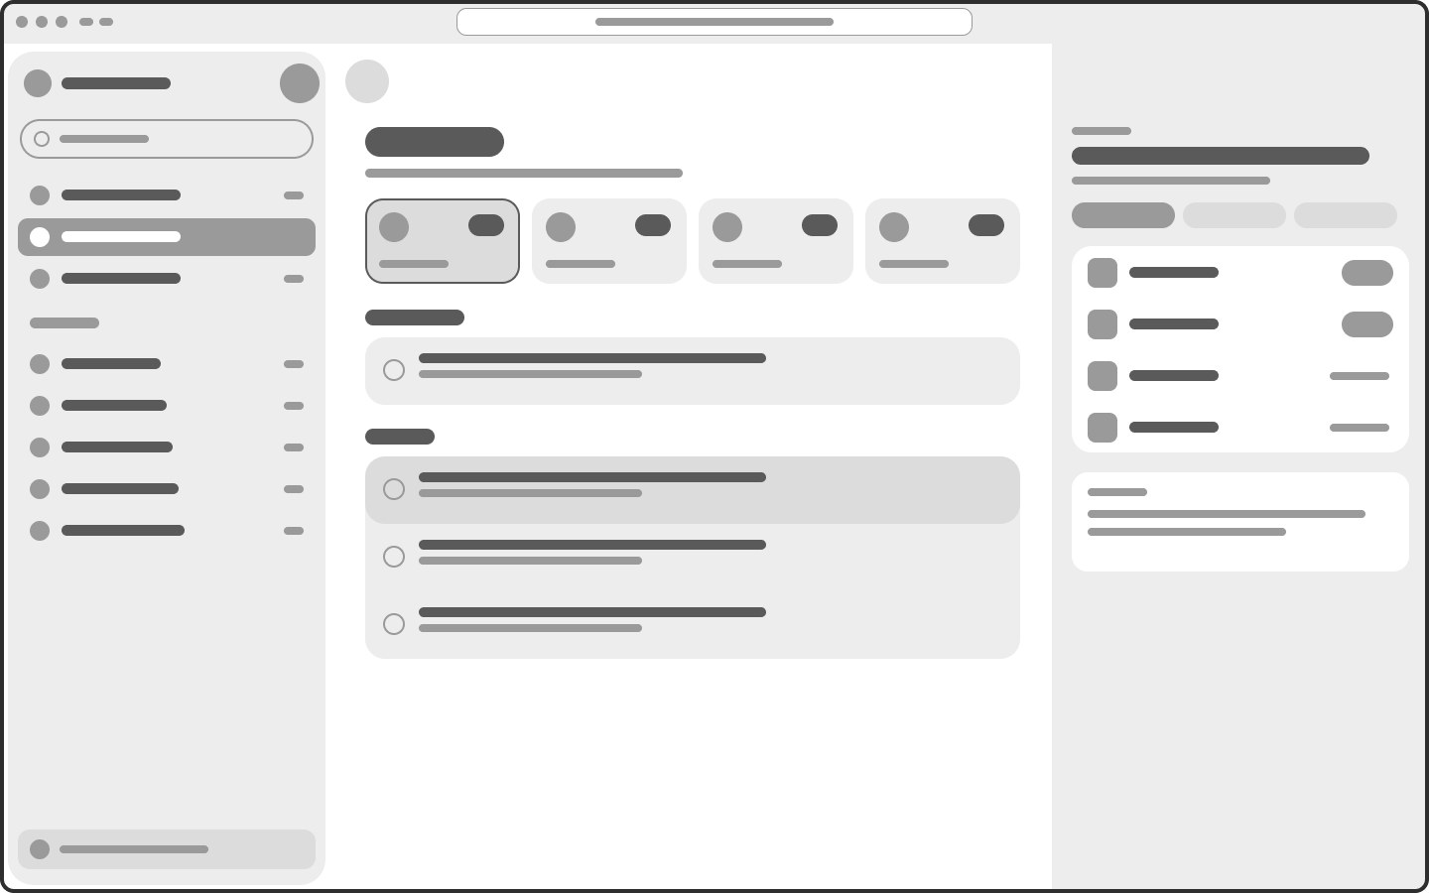
Figure 24. Web wireframe W05 Tasks + reminder inspector
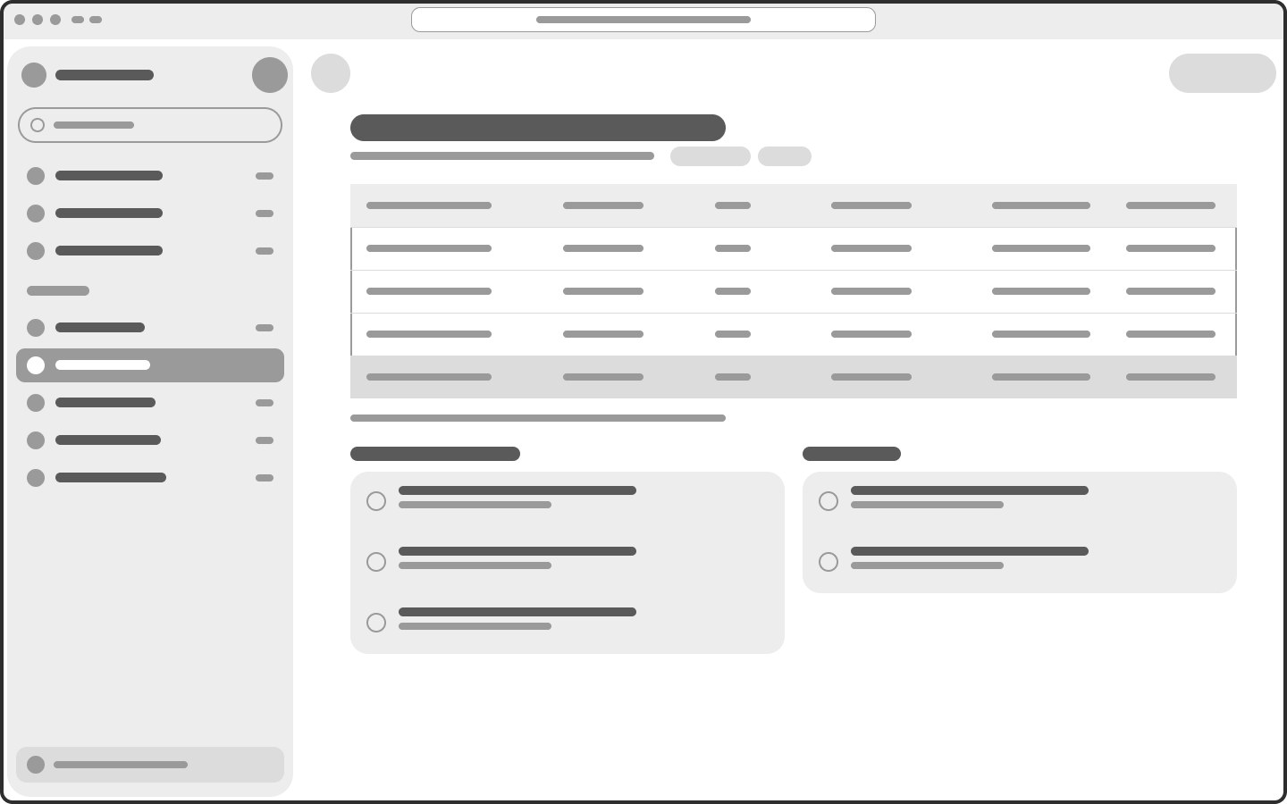
Figure 25. Web wireframe W06 Tutoring — tuition table
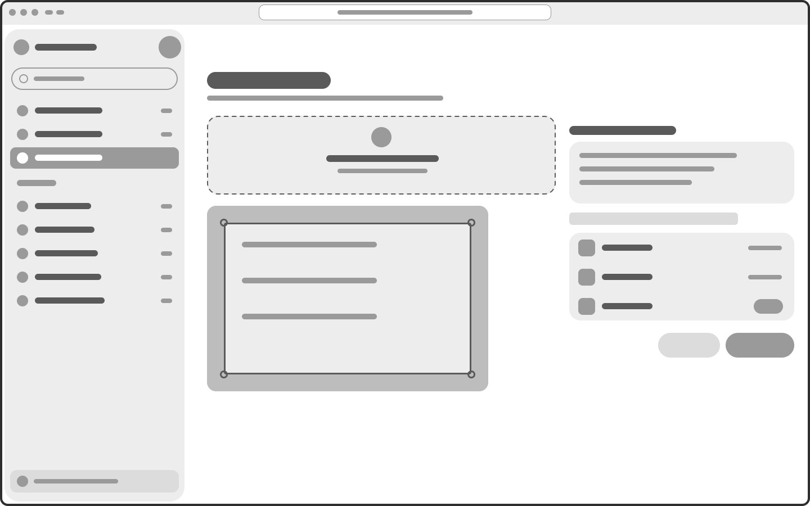
Figure 26. Web wireframe W07 Import scan — drag & drop
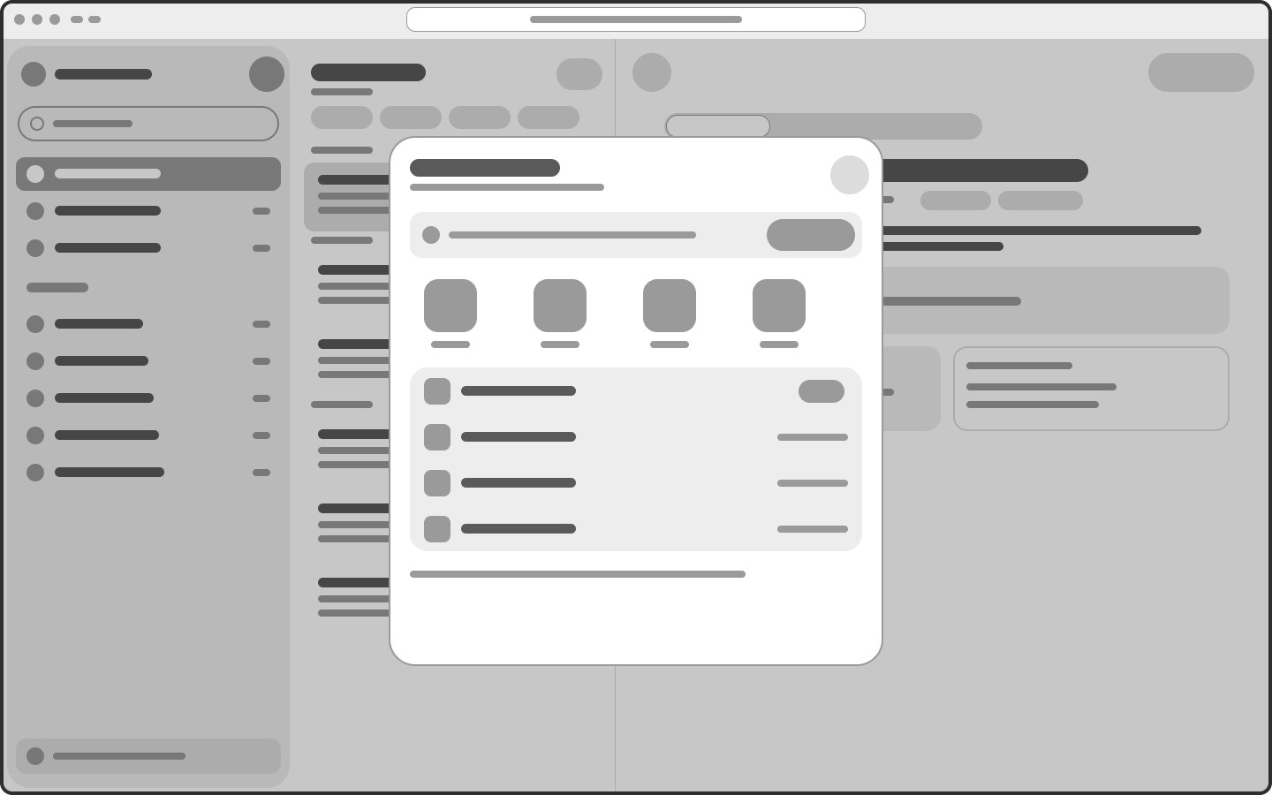
Figure 27. Web wireframe W08 Share & export dialog
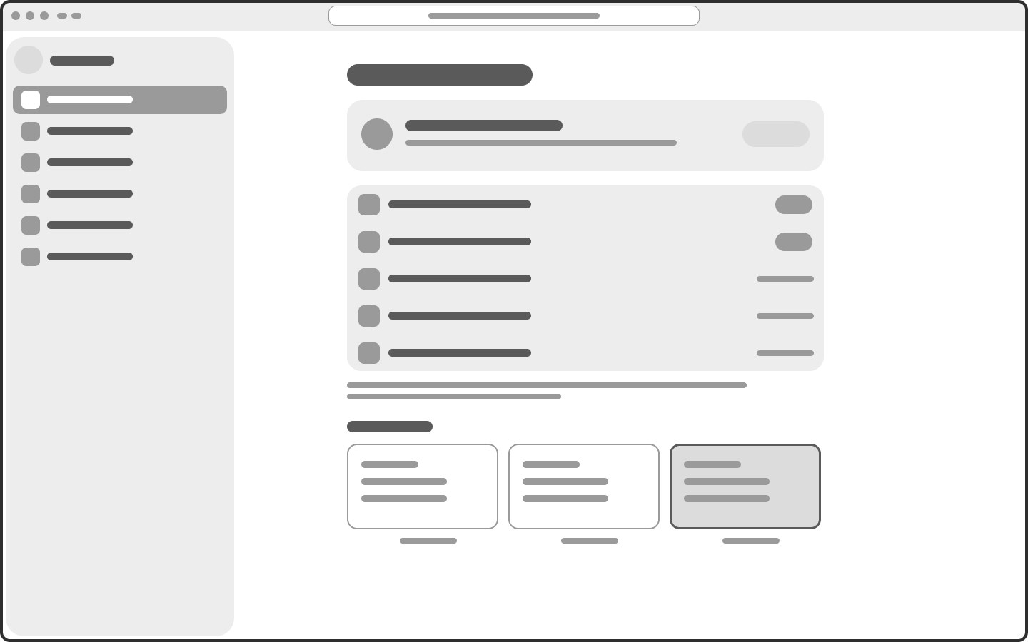
Figure 28. Web wireframe W09 Settings — sync & backup
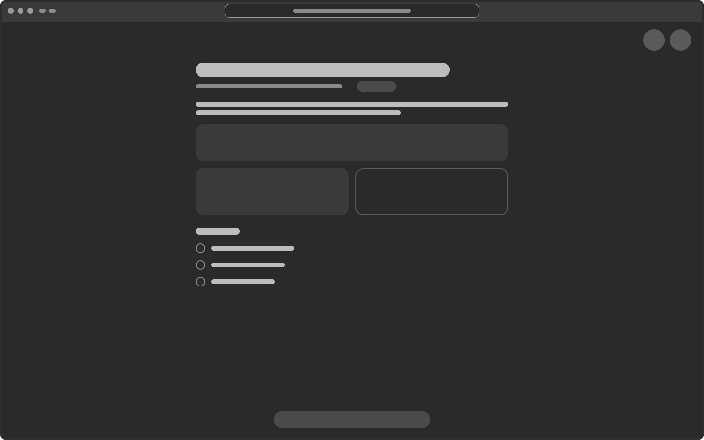
Figure 29. Web wireframe W10 Dark + Focus mode
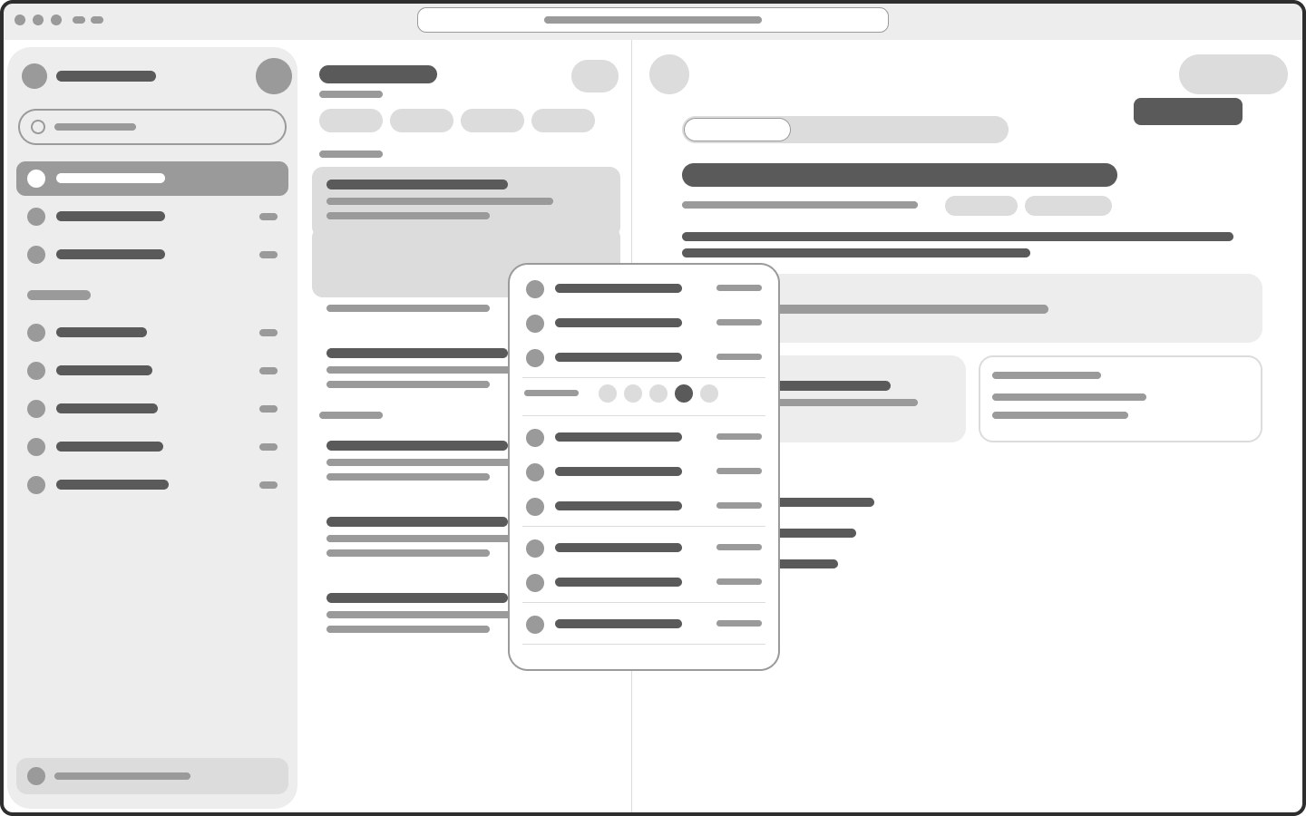
Figure 30. Web wireframe W11 Right-click menu + tooltips
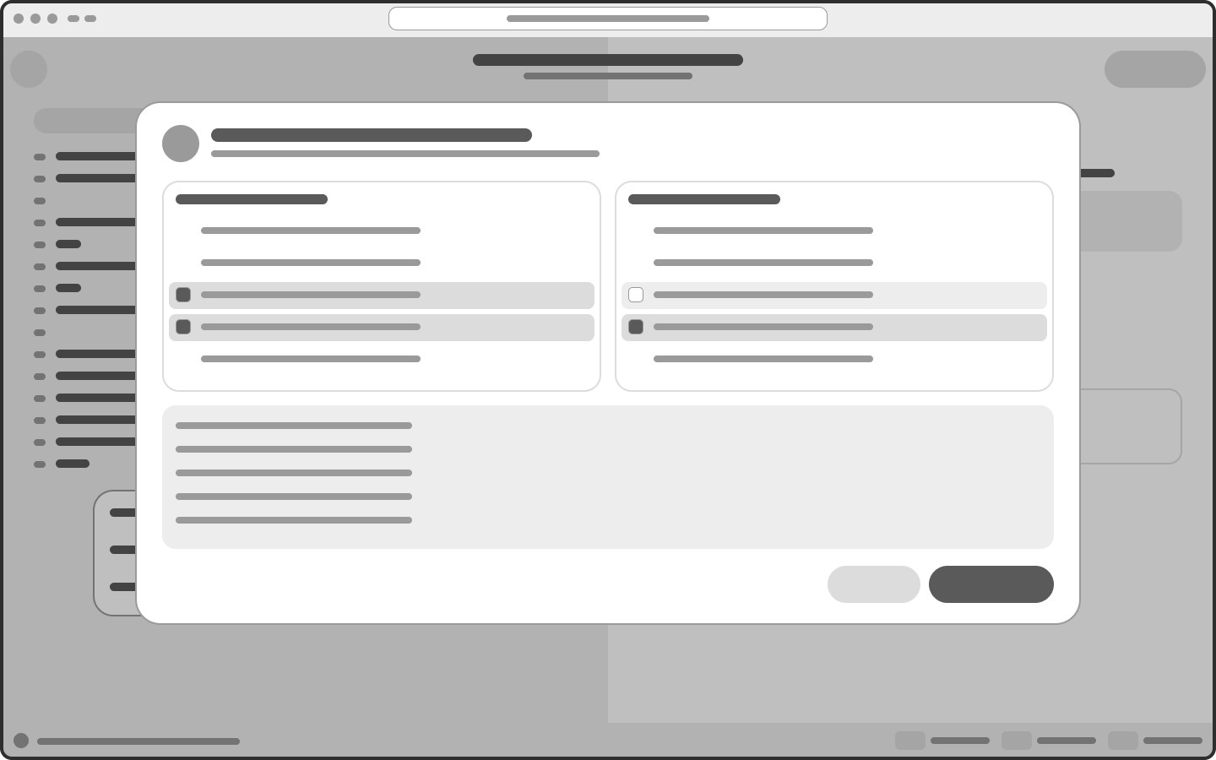
Figure 31. Web wireframe W12 Sync conflict — merge line by line

IV. Test cases
Functional test cases verify that each key flow of the prototype works as specified; the usability test plan below measures whether real users can complete the persona tasks efficiently.
ID | Test case | Precondition | Test steps | Expected result | Screens
TC-01 | Quick capture a text note | App installed; user on Home | 1. Tap “+”  2. Choose Văn bản (Text)  3. Type a title and content  4. Go back | Note appears at the top of “Hôm nay” with badge “Đã lưu”; total taps to start writing ≤ 2 | 02 → 03 → 06
TC-02 | Scan a whiteboard and make it searchable | Camera permission granted | 1. Tap “+” → Quét ảnh  2. Point at the board until edges are detected  3. Wait for auto-capture  4. Review recognized text, edit one word  5. Choose folder, tap Lưu | Progress “Đang nhận dạng chữ…” shown, Save disabled until done; note saved with photo + editable text | 04 → 21 → 05
TC-03 | Find text inside a photo | TC-02 completed | 1. Tap Search  2. Type “tích phân”  3. Filter “Ảnh & chữ viết tay”  4. Open the first result | Results within 2 s, match highlighted in the photo; works with Wi-Fi off | 09 / W04
TC-04 | Insert a formula without LaTeX | Note open in Live Preview | 1. Tap Σ on the toolbar  2. Tap ∫, fill limits 0 and 2π  3. Tap Insert | Rendered formula appears in the note; LaTeX source visible only in Source mode | 06 → 08
TC-05 | Set a reminder on a checklist item | Note contains an unchecked item | 1. Tap the bell next to the item  2. Pick “Tối nay 18:00”  3. Tap ✓ | Item shows orange due label; appears in Tasks › Hôm nay; notification fires at 18:00 with “Đã thu ✓” action | 06 → 11 → 10 → 25
TC-06 | Work offline and sync later | Airplane mode on | 1. Edit a note  2. Observe the banner  3. Turn Wi-Fi on | Banner “Đang offline — vẫn lưu trên máy”; changes sync automatically when online; badge “Đã đồng bộ” | 22 → 02
TC-07 | Resolve a sync conflict | Same note edited on phone (offline) and web | 1. Reconnect  2. In the merge dialog, select lines to keep  3. Tap “Gộp các dòng đã chọn” | Merged note contains all selected lines; both originals kept in version history | 23 / W12
TC-08 | Delete and undo | At least one note exists | 1. Swipe a note → Delete  2. Tap Hoàn tác in the toast | Note restored to the same position; without undo it stays 30 days in Recently Deleted | 16 → 02
TC-09 | Permanently delete with confirmation | Notes in Recently Deleted | 1. Open Recently Deleted  2. Select 3 notes → Delete permanently | Alert “Xoá vĩnh viễn 3 ghi chú?” with safe default “Giữ lại”; notes removed only after confirming | 14 → 24
TC-10 | Colour label and pin from the ⋯ menu | Note open | 1. Tap ⋯  2. Tap Ghim and choose the orange label | Note pinned at top of Home with orange dot; menu shows grouped actions and destructive action last | 06 → 19
TC-11 | Share a read-only link | Note open | 1. Tap Share  2. Toggle Link chỉ xem, set expiry  3. Tap Sao chép link | Link copied; recipient can view in a browser without an account | 13 / W08
TC-12 | Keyboard-first editing on web | Web app open on Windows | 1. Press Ctrl K, type “ins”, Enter on Insert formula  2. Press Ctrl E to switch to Source  3. Right-click a note in the list | Palette filters commands with shortcuts; mode switches; context menu shows Ctrl shortcuts | W03 · W02 · W11
Usability test plan
Task given to participant | Persona | Success criterion | Metric
“Save this whiteboard photo so you can find it later” | Thư | Note saved with recognized text | ≤ 4 taps · ≤ 20 s
“Find the note that mentions ‘tích phân’ in a photo” | Both | Correct result opened | ≤ 3 actions · ≤ 10 s
“Remind yourself to collect Minh’s fee tonight” | Thư | Reminder set on checklist item | ≤ 4 taps
“Insert ∫ from 0 to 2π of f(θ)dθ without typing code” | Thư | Formula inserted correctly | 0 errors
“Write the same formula in Source mode and export .md” | Đức Anh | Valid .md with LaTeX | ≤ 60 s
“You deleted a note by mistake — get it back” | Both | Note restored | ≤ 2 taps
Method: 5 participants per persona, think-aloud protocol, System Usability Scale (SUS) questionnaire after the tasks; any task under 80% success is redesigned in the next iteration.
Heuristic evaluation (v1 → v2)
Heuristic | Problem found in v1 | Severity | Fix in v2
Visibility of system status | No processing / offline / syncing states | 3 | Screens 21, 22 and sync badge on every list
Match with real world | Jargon (OCR, =SUM, .md) in Simple mode; mixed languages | 3 | Vietnamese, jargon-free copy; Settings › Language
User control & freedom | ⋯ jumped straight to Settings; no Cancel while processing | 3 | Full ⋯ menus (19, 20, W11); Cancel on 21
Consistency & standards | ⌘ shown to Windows users; two icon styles | 2 | Ctrl/⌘ by OS; one icon set rule
Error prevention | Permanent delete without confirmation | 4 | Confirmation alert only for irreversible actions (24)
Recognition rather than recall | Icon-only buttons without labels | 2 | Tooltips with shortcuts; labelled menus
Help users recover from errors | No UI for sync conflicts | 4 | Line-by-line merge (23, W12) + version history (27)

PART 2 – PROTOTYPE
The hi-fi prototype is built in Figma on top of the official Apple iOS & iPadOS 27 library (real components: status bar, toolbars, Liquid Glass buttons, tab bar, lists, sheets, alerts, keyboard), with a colour system defined on the colour wheel and a component state matrix.
Figma design file: https://www.figma.com/design/VWLZhe9YBBkKE3Fl8mNfH5/Oppotunities

Visual design system
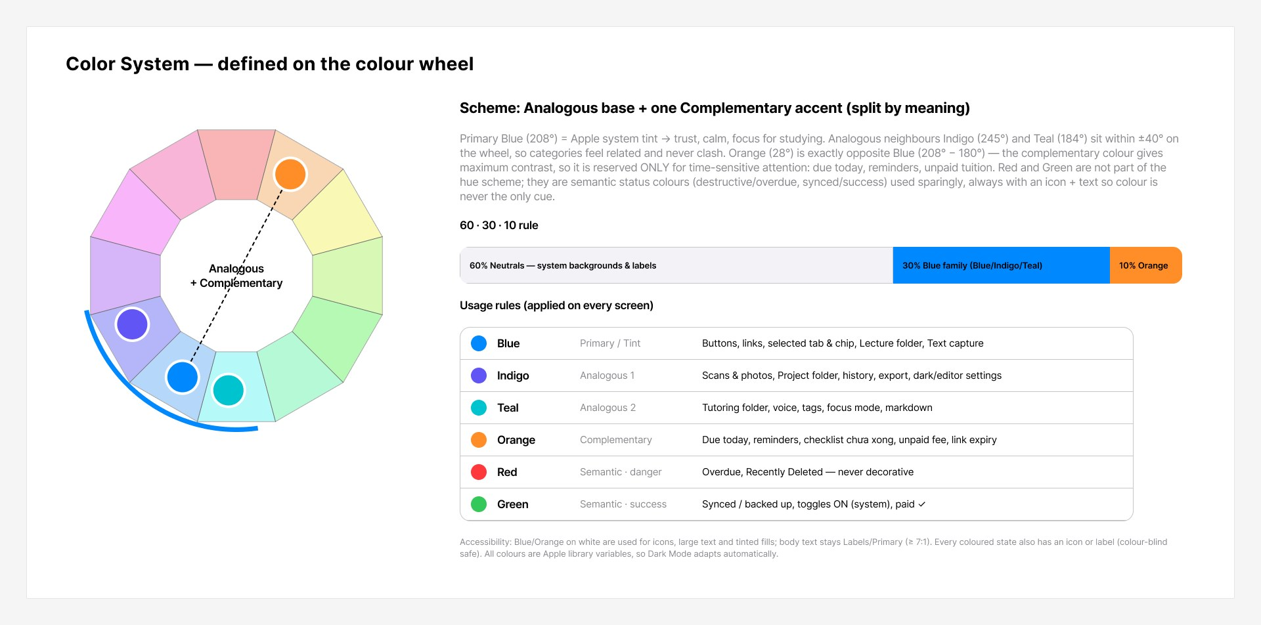
Figure 32. Colour system — Blue primary (208°), analogous Indigo/Teal, complementary Orange (28°), 60-30-10 rule
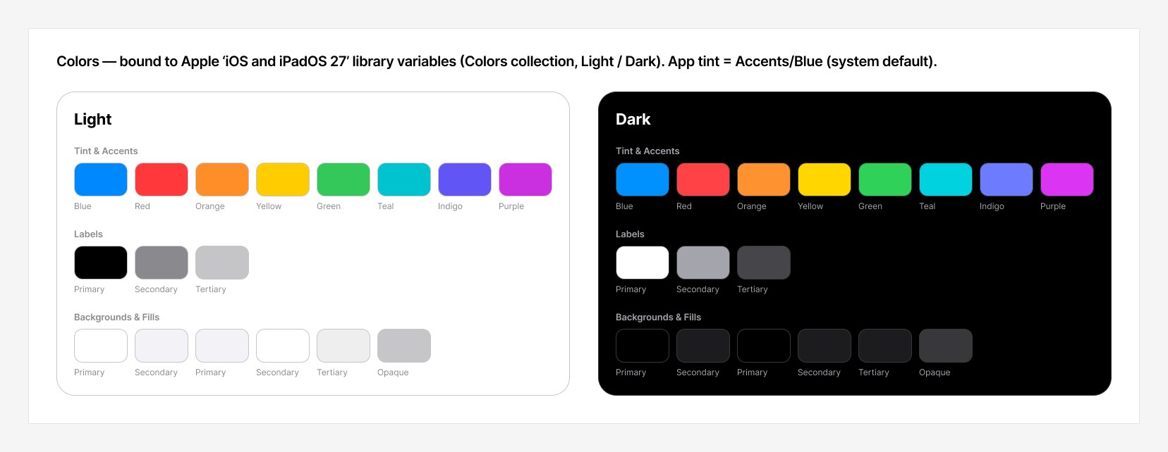
Figure 33. Apple iOS 27 system colour variables, Light and Dark modes
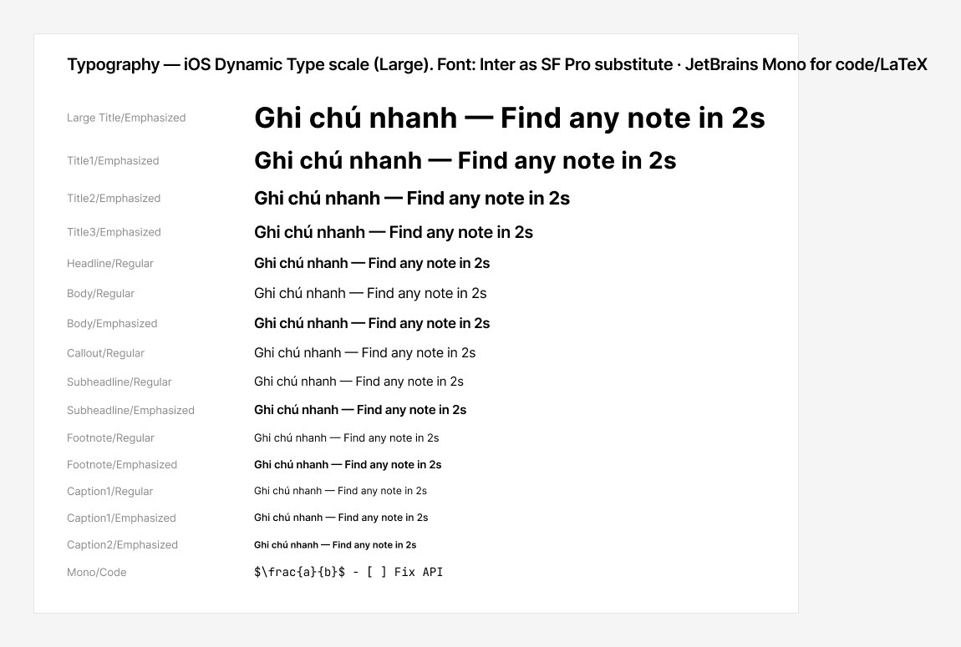
Figure 34. Typography — Dynamic Type scale (Large default)
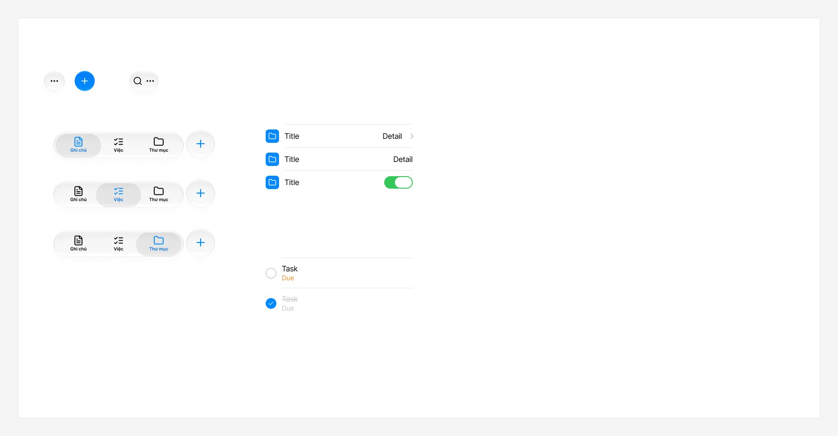
Figure 35. Components derived from the Apple kit — glass buttons, tab bar, list rows, task rows
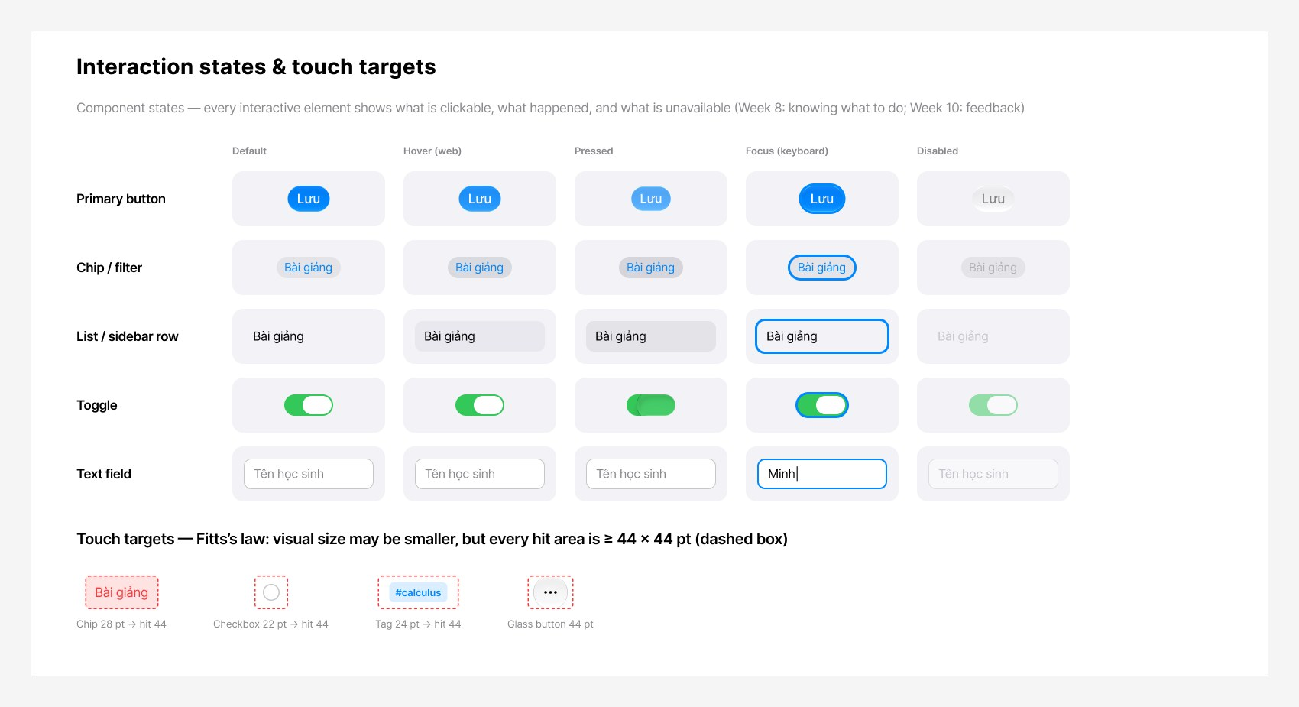
Figure 36. Interaction states (default, hover, pressed, focus, disabled) and 44 pt touch targets
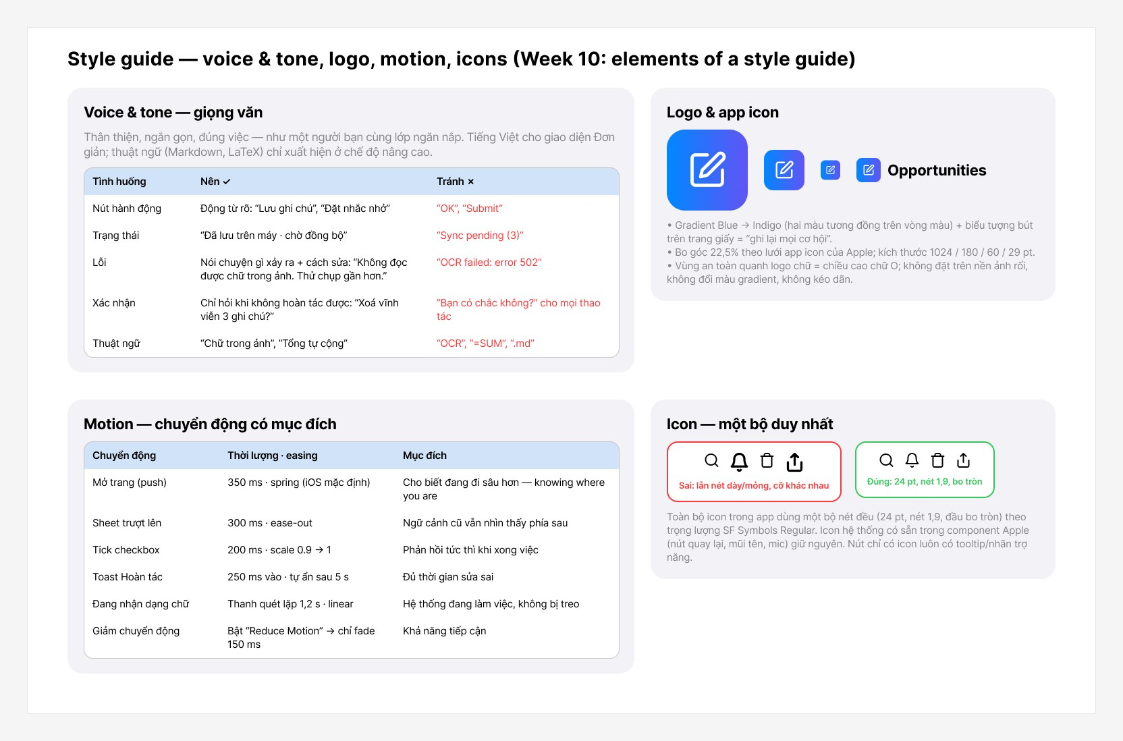
Figure 37. Style guide — voice & tone, logo/app icon, motion, icon rules

I. Mobile app
Mobile prototype (Figma, start at 01 Onboarding): https://www.figma.com/proto/VWLZhe9YBBkKE3Fl8mNfH5/Oppotunities?page-id=6%3A5&node-id=41-2326&starting-point-node-id=41%3A2326&scaling=scale-down
27 iPhone screens grouped into six flows; every screen is linked with hotspots (tap “+”, menus, tabs, buttons) so the main scenarios can be played end to end.
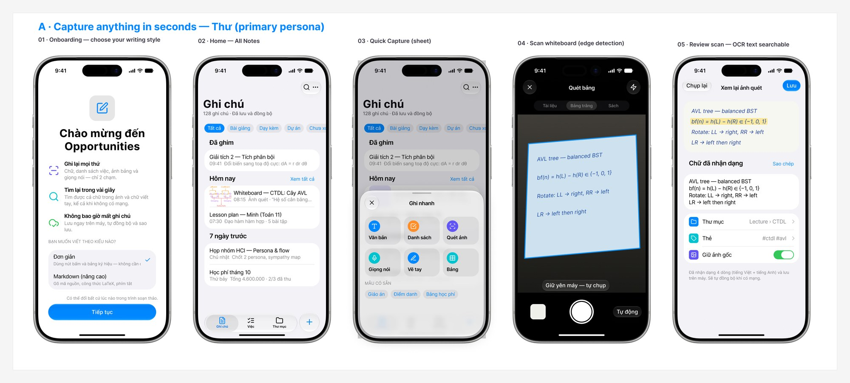
Figure 38. Mobile A — Capture anything in seconds: onboarding, home, quick capture sheet, scan whiteboard, review scan
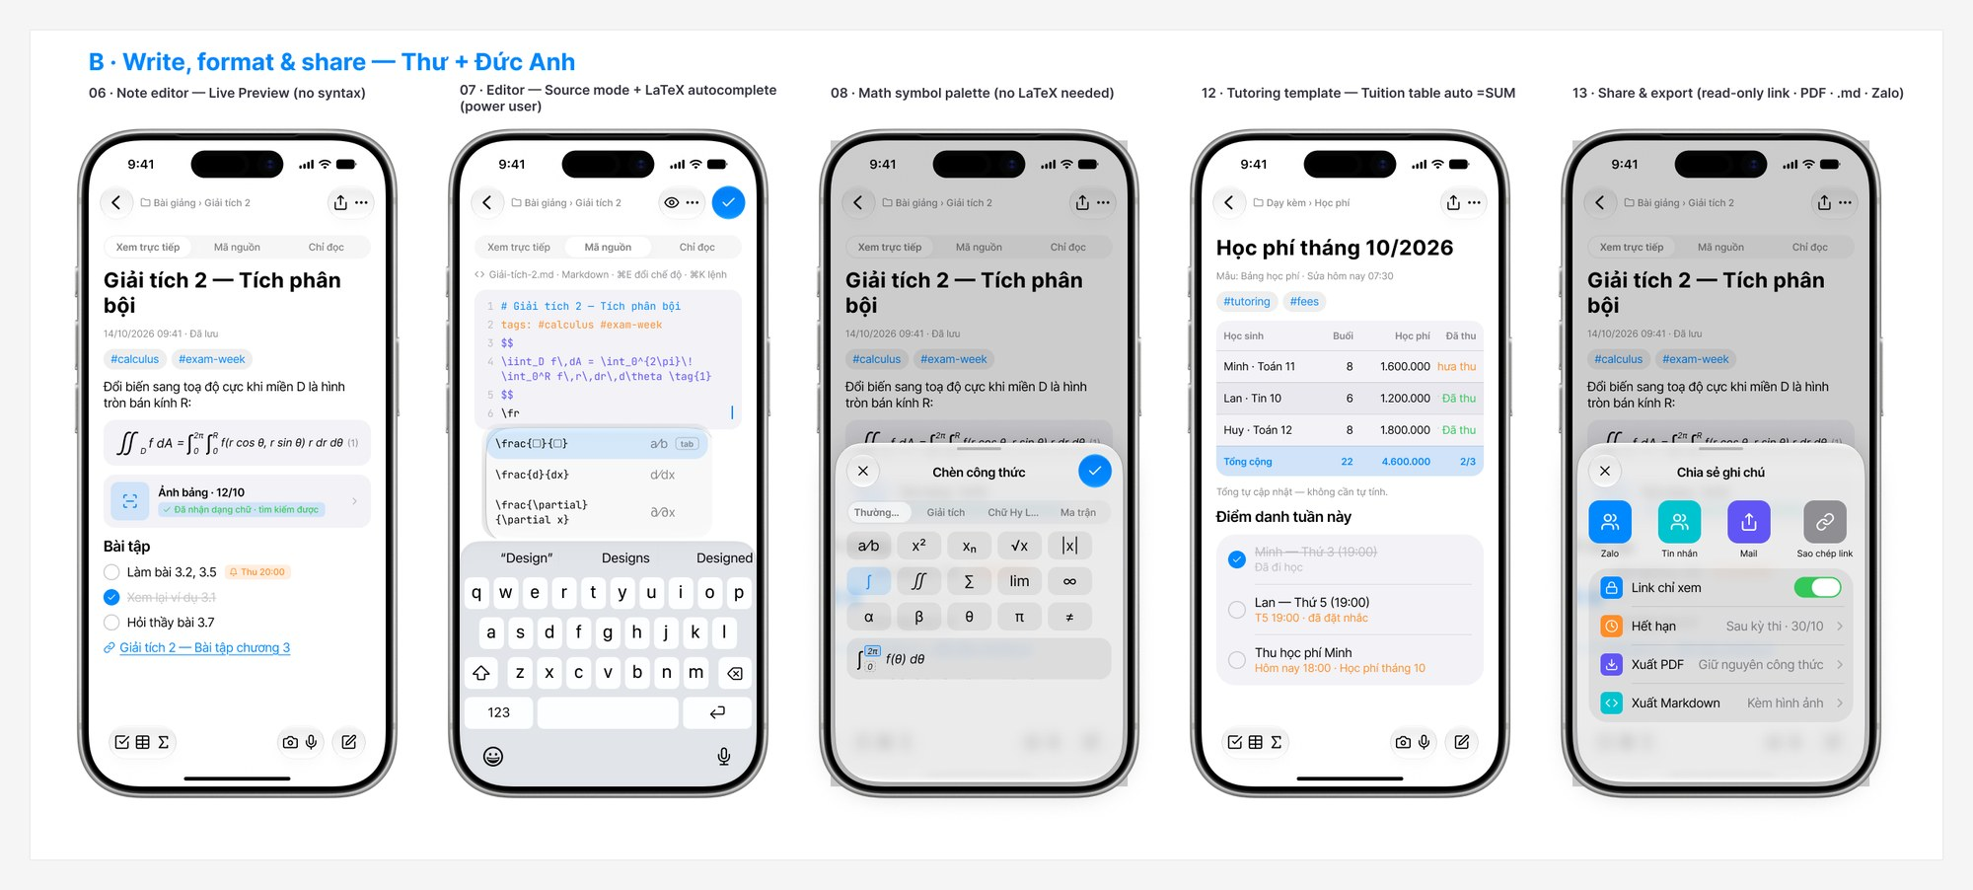
Figure 39. Mobile B — Write, format & share: Live Preview editor, Source mode, math palette, tuition table, share sheet
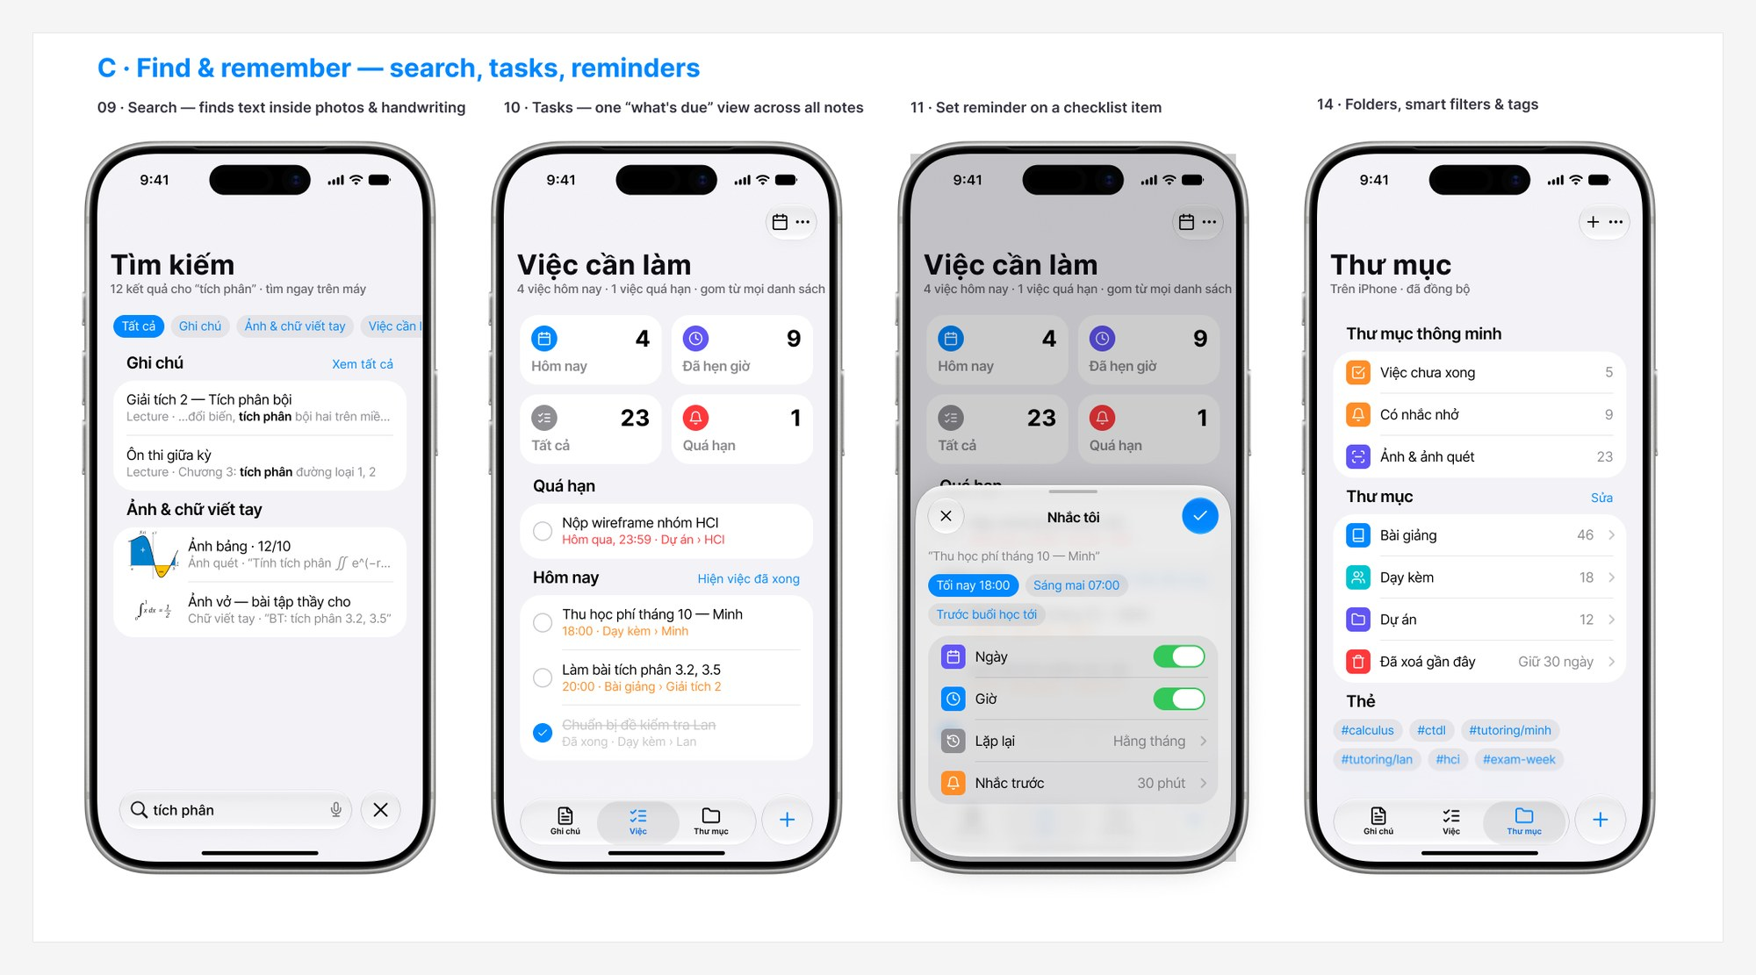
Figure 40. Mobile C — Find & remember: search inside photos, tasks, reminder sheet, folders
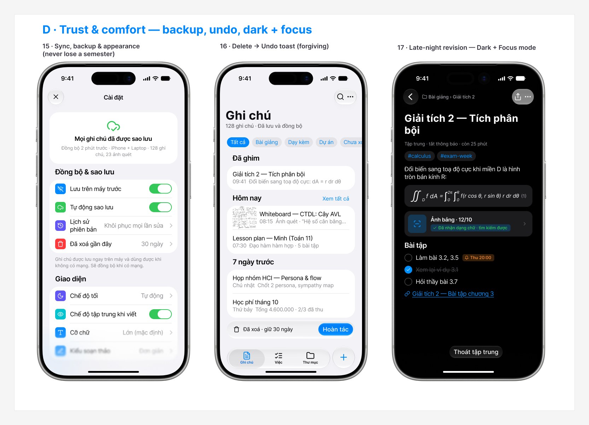
Figure 41. Mobile D — Trust & comfort: sync & backup settings, undo toast, dark + focus mode
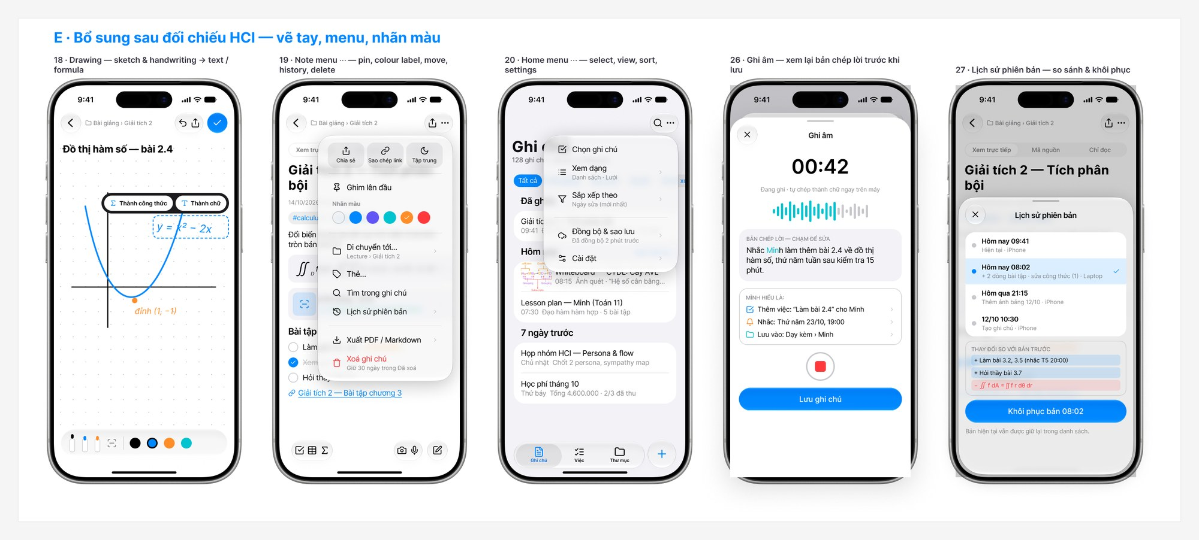
Figure 42. Mobile E — Drawing, note menu with colour labels, home menu, voice note transcript, version history
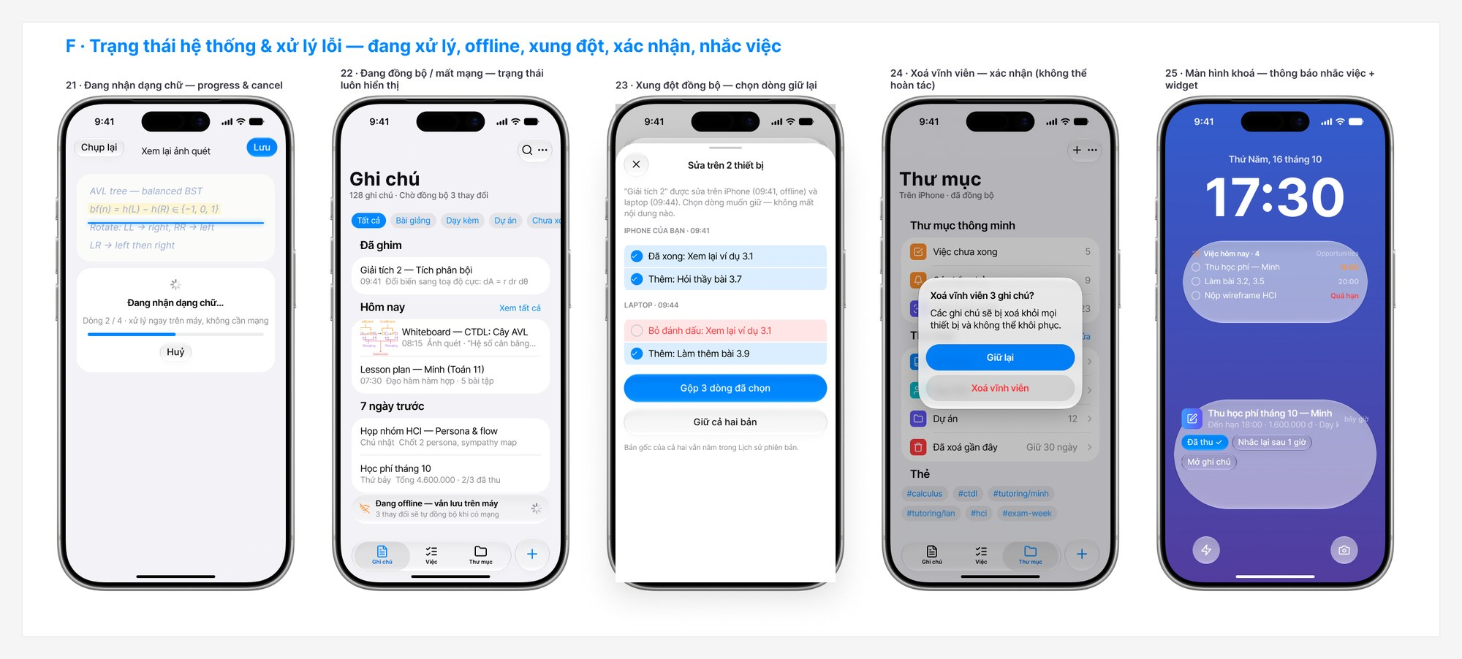
Figure 43. Mobile F — Recognizing text, offline banner, sync conflict, permanent delete alert, lock-screen notification & widget

II. Web
Web app prototype (Figma, start at W01): https://www.figma.com/proto/VWLZhe9YBBkKE3Fl8mNfH5/Oppotunities?page-id=64%3A3&node-id=64-6&starting-point-node-id=64%3A6&scaling=scale-down
12 desktop screens (1440 × 900) using the iPad sidebar and toolbar components: a 3-column workspace for Thư on her Windows laptop and keyboard-first tools for Đức Anh.
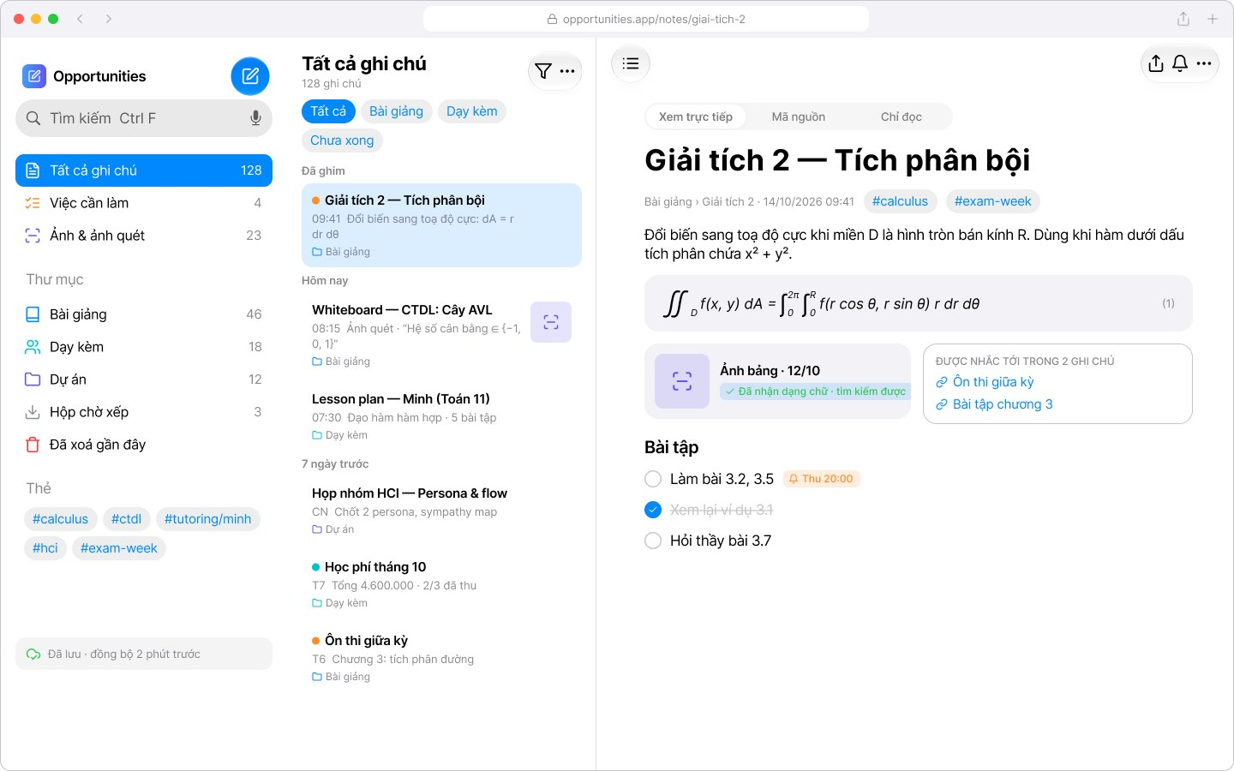
Figure 44. W01 — Notes — sidebar, note list with colour labels and editor in Live Preview
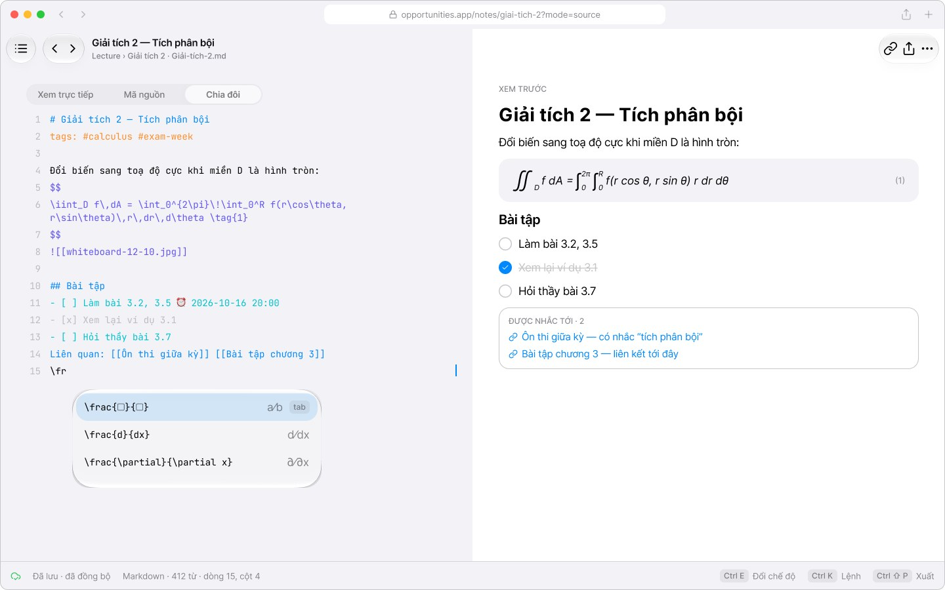
Figure 45. W02 — Editor — Source | Preview split with LaTeX autocomplete and shortcut status bar
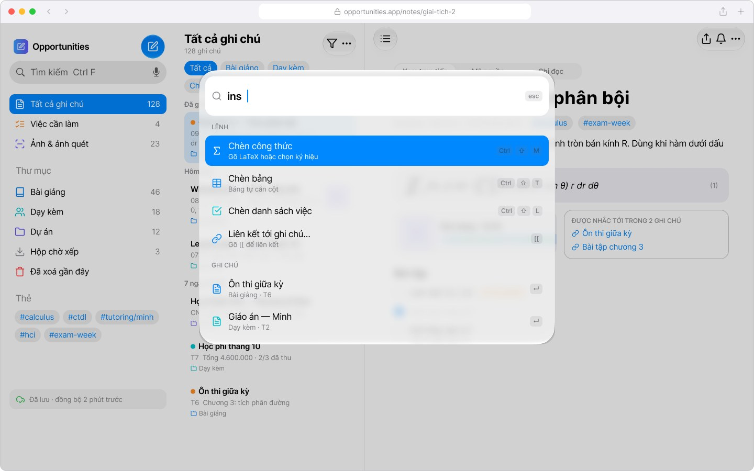
Figure 46. W03 — Command palette (Ctrl K) listing commands with their shortcuts
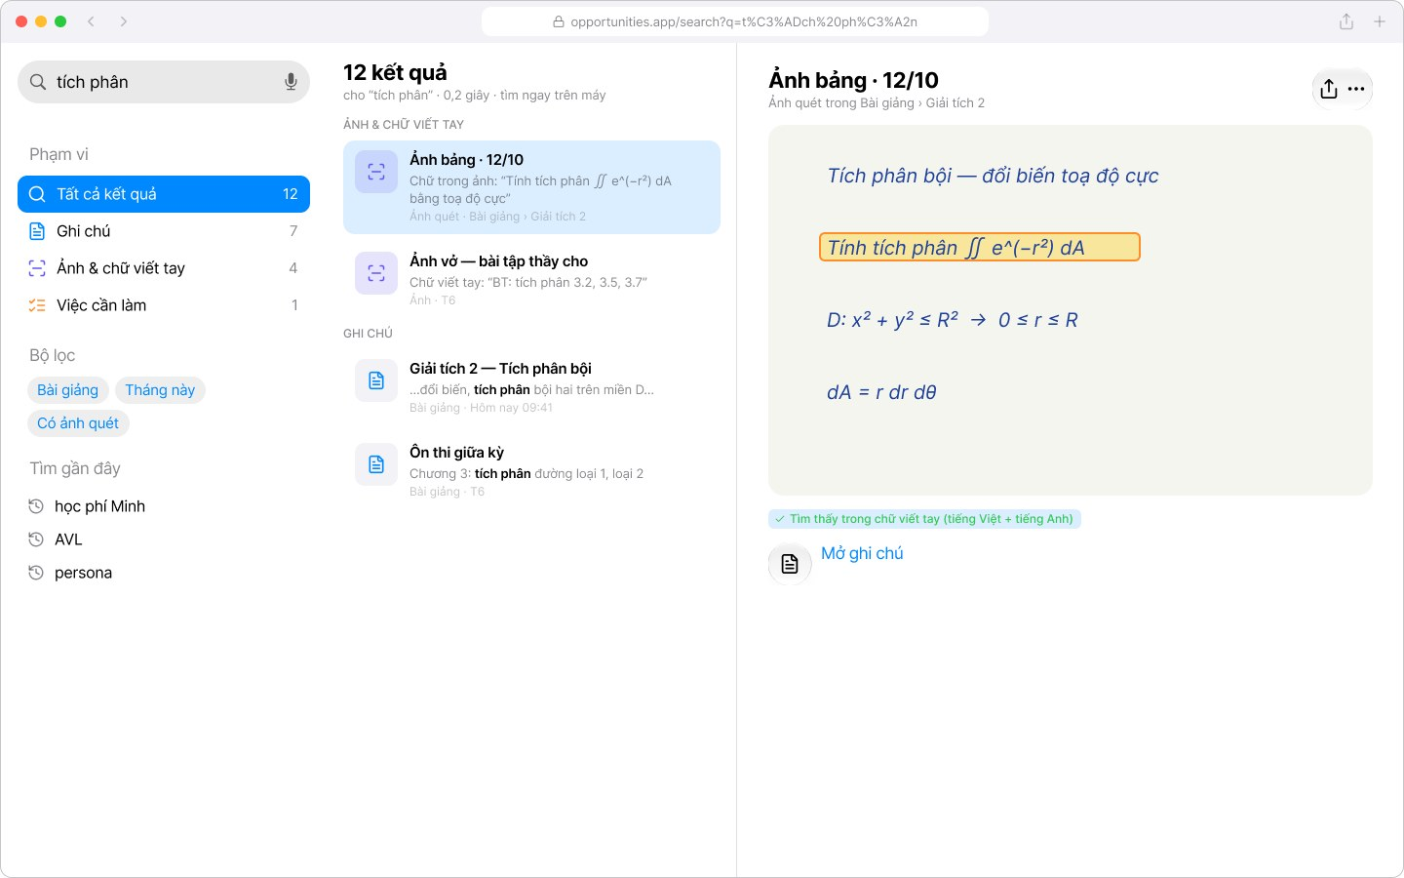
Figure 47. W04 — Search — scope filters, results, and the OCR match boxed on the photo
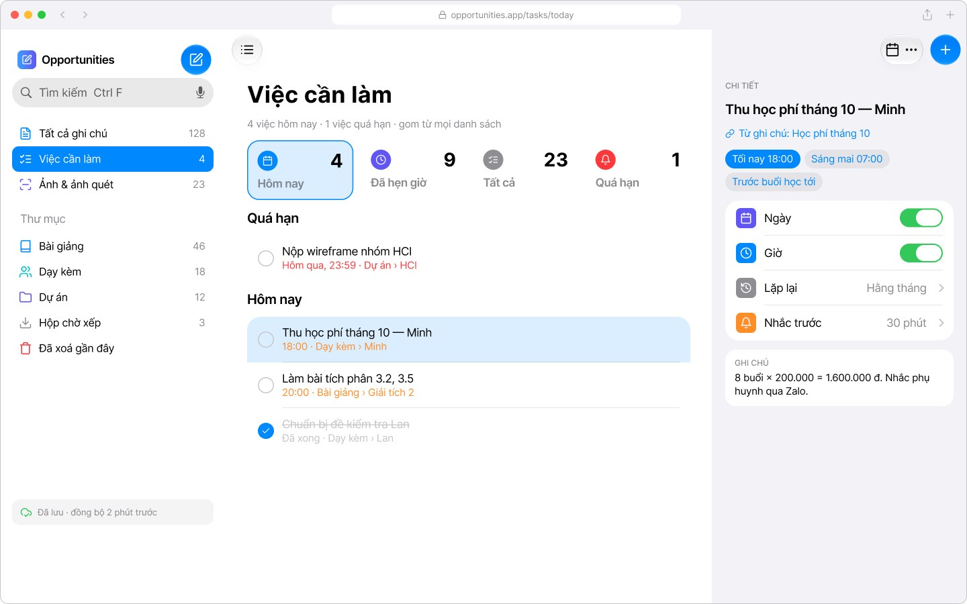
Figure 48. W05 — Tasks — smart lists and the reminder inspector
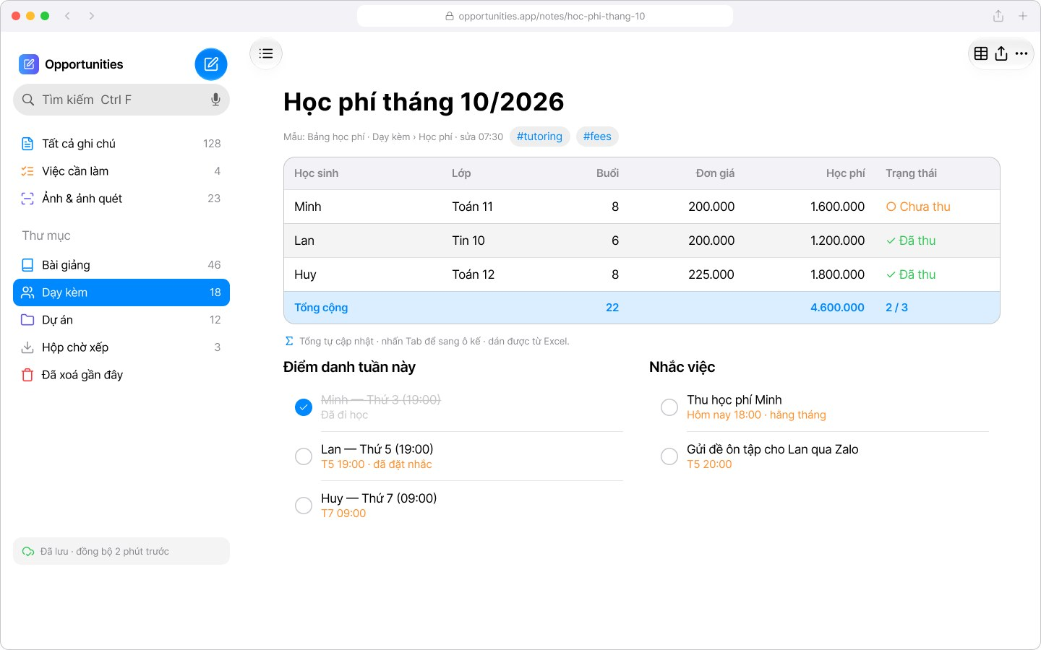
Figure 49. W06 — Tutoring — tuition table with zebra rows and automatic total, attendance
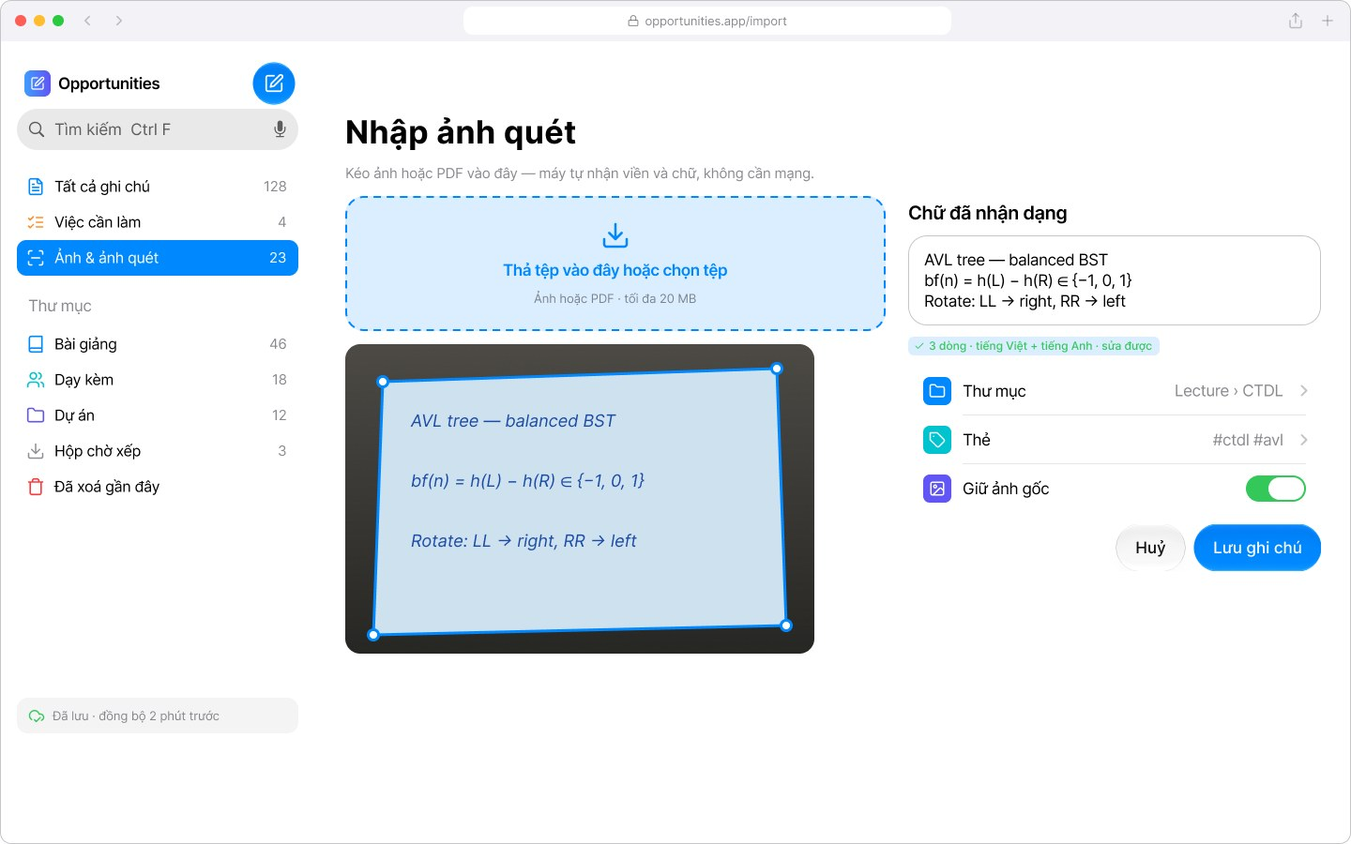
Figure 50. W07 — Import scan — drag & drop, edge correction and recognized text review
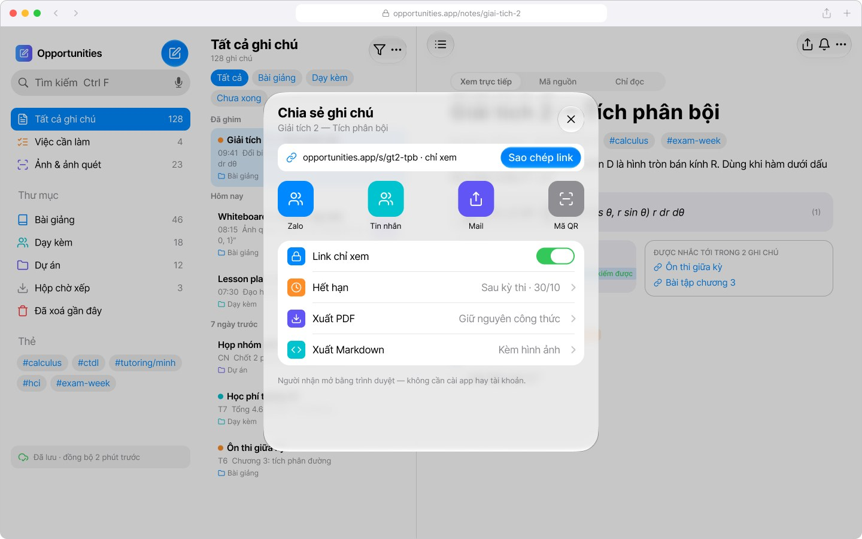
Figure 51. W08 — Share & export dialog — read-only link, expiry, PDF / Markdown
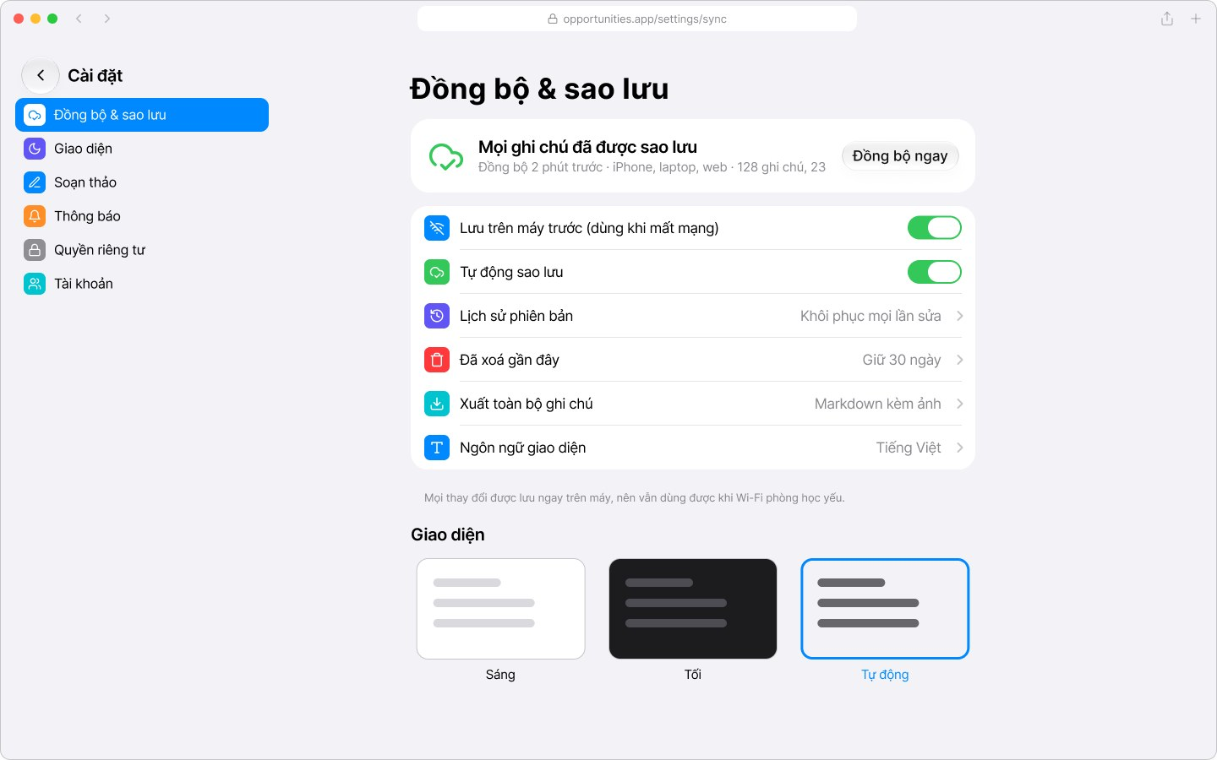
Figure 52. W09 — Settings — sync, backup, language and appearance
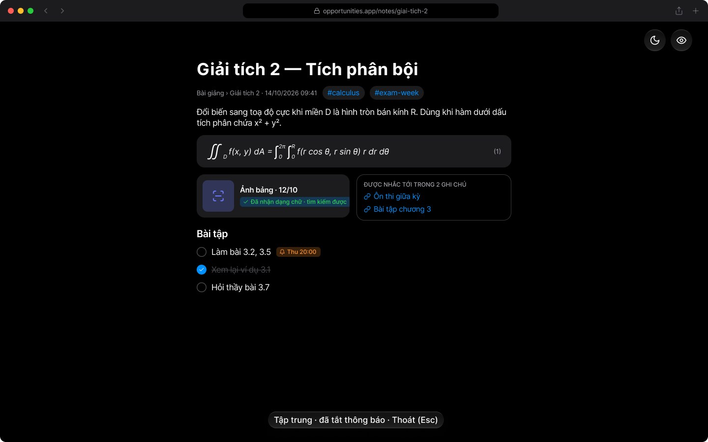
Figure 53. W10 — Dark + Focus mode for late-night revision
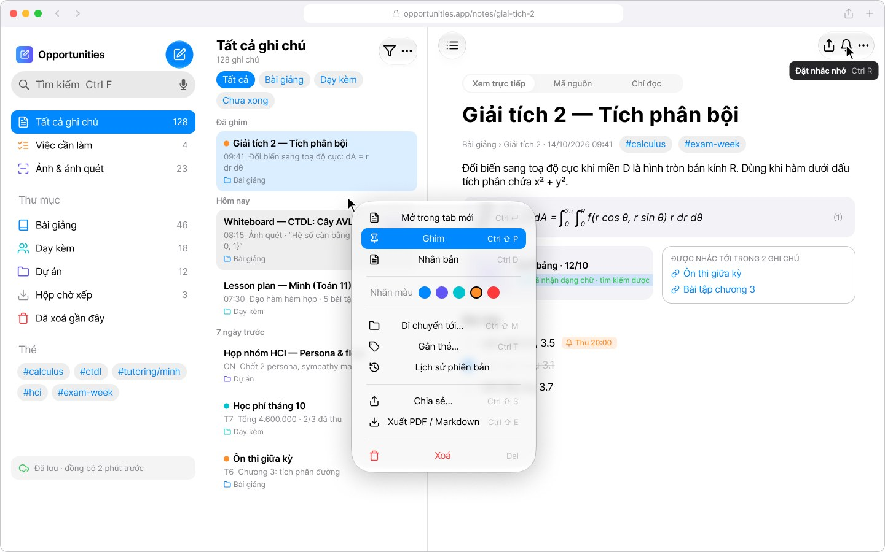
Figure 54. W11 — Right-click menu and tooltips with Ctrl shortcuts
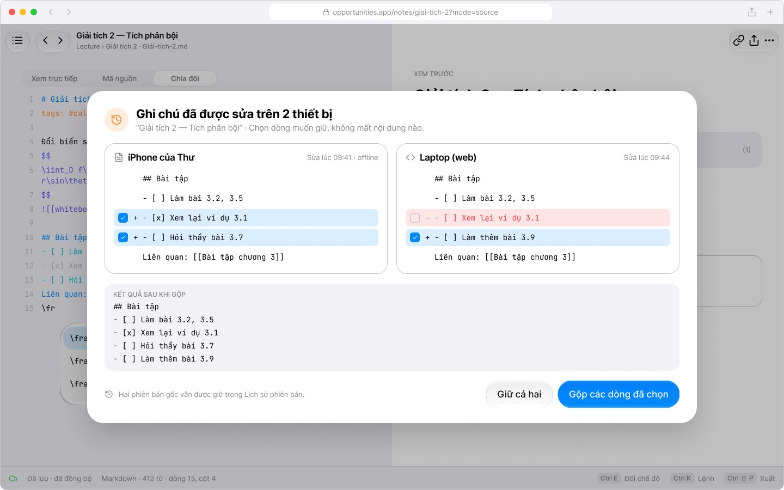
Figure 55. W12 — Sync conflict — compare and merge line by line
— THE END —

